**Bactericidal and Immunomodulatory Effects of Handeuleum Leaf Extract (*Graptophyllum pictum*) Against the Attack of *Vibrio parahaemolyticus* Bacteria on Asian Sea Bass (*Lates calcarifer* Bloch 1790)**

Muhammad Darmawan1, Hanesty Resta Windari1, Ofriani Fatrika2, Agus Setyawan1

1Department of Fisheries and Marine Sciences, Faculty of Agriculture, University of Lampung, Jl. Soemantri Brojonegoro, Bandar Lampung 35145, Indonesia; 2 Department of Chemistry, Faculty of Mathematics and Natural Sciences, University of Lampung, Jl. Soemantri Brojonegoro, Bandar Lampung 35145, Indonesia. Corresponding author: A. Setyawan, agus.setyawan@fp.unila.ac.id

**Abstract.** *Vibrio parahaemolyticus* is one of the opportunistic pathogens of the bacterial group that can threaten at any time and cause mortality to reach 90% in the cultivation of Asian sea bass (*Lates calcarifer*). Until now, various bacteria control techniques it was considered less effective and even *Vibrio* bacteria have the potential to be resistant to inappropriate antibiotic use. Therefore, antibacterial alternatives are needed, especially anti-*Vibrio* that is effective, safe and environmentally friendly. One of the herbs that has the potential as an antibacterial is the handeuleum leaf (*Graptophyllum pictum*). So far, there has been no study of the activity of handeuleum leaf extract as anti-*Vibrio*. However, handeuleum leaf extracts are shown to have antibacterial content such as non-toxic alkaloids, flavonoids, steroids, saponins and tannins. The purpose of writing this narrative review is to examine the potential of handeuleum leaves (*Graptophyllum pictum*) as anti-*Vibrio parahaemolyticus* in the cultivation of Asian sea bass (*Lates calcarifer*) based on a previous reference. The method that is done is to search and collect libraries in the form of articles and scientific journals both national and international, then done analysis and comparison of literature. Handeuleum leaves have several compounds such as hexadeconoic acid (palmitit acid), dodecanoic acid (lauric acid), hexadecanoic acid (methyl ester), 9,12,15-octadecatrienoic acid, tetradecanoic acid (myrist), and octadeconoic acid which has the potential to be an anti-*Vibrio parahaemolyticus* candidate to prevent and treat vibriosis disease in Asian sea bass.

**Keywords:** anti-bacteria, handeuleum leaves, *Lates calcarifer*, vibriosis

**Introduction.** Asian sea bass (*Lates calcarifer*) is a fish commodity that has high economic value and relatively fast growth, which can reach a daily growth rate of 0.51% (Rayes et al., 2013). The production of snapper in Indonesia continues to increase. In the last five years, snapper production has shown a significant increase in production, namely 8.85% per year (KKP, 2020). However, this increase in production was also followed by the appearance of various diseases in Asian sea bass cultivation. One of the diseases that often attack Asian sea bass in floating net cages is a bacterial infection of vibriosis. Vibriosis is a serious bacterial disease that can affect production yields in aquaculture. This disease is caused by the bacteria *Vibrio* sp. which can cause mortality reaching 90% with early clinical symptoms, namely the fish will experience anorexia, loss of appetite, and loss of balance. At the acute level, vibriosis causes the dorsal and caudal fins to experience thinning with a blackened skin surface like burning (Fitratunisa, 2016).

Treatment of bacterial diseases such as vibriosis is currently given antibiotics which are expected to be able to control the spread of this disease. Several types of antibiotics are often used such as chloramphenicol, oxytetracycline, and erythromycin. However, excessive and continuous use will have a bad impact on fish and the environment. Besides, the use of antibiotics is also able to cause resistance to these bacteria so that their handling will be even more difficult (Andayani, 2009). Taking into account the bad effects of using these antibiotics, it is important to use herbal medicines as antibacterials. In Indonesia, the use of herbal plants as natural antibacterials has long been used by humans, but in the fisheries sector, it is still not widely used (Oktaviani et al., 2019). One of the herbal plants that have potential as an antibacterial is a handeuleum leaf (*Graptophyllum pictum*). Handeuleum leaves have been shown to contain antibacterial properties such as non-toxic alkaloids, flavonoids, steroids, saponins, and tannins (Sya'haya & Iyos, 2016). This plant has long been used as an antidiuretic, hemorrhoids, constipation, cooking boils, bruises, menstrual smoothing, and anti-inflammatory in humans (Dalimartha, 1999 in Ummanah, 2017). So far, there has been no study on the use of handeuleum leaf extract as an antibacterial agent in fish. Therefore it is important to study the potential of handeuleum leaf extract as an antibacterial agent for vibriosis disease in Asian sea bass.

**Method.** The narrative review writing method is carried out by searching and collecting literature in the form of articles and scientific journals of research results and e-books that are available online and accessed from Google Scholar (<https://scholar.google.co.id/>), Google (<https://www.google.com>), PubChem (<http://pubchem.ncbi.nlm.nih.gov/>), PassOnline (<http://www.pharmaexpert.ru/passonline/>), and several official scientific journal websites. Then analyzed and cited the literature from all articles obtained and organized. Keywords used include handeuleum leaves and *Vibrio parahaemolyticus*, but they are not limited to that. The data obtained were then summarized and conclusions were drawn and then arranged in such a way as to show the potential of handeuleum leaves as an antibacterial, especially in *Vibrio parahaemolyticus* bacteria.

**Results And Discussion**

1. ***Vibrio parahaemolyticus***

*Vibrio parahaemolyticus* is a halophilic Gram negative bacteria that can be found in estuary, marine and coastal environments (Lin et al., 2019). Vibrio bacteria are known as the causative agent of acute gastroenteritis in humans through contaminated seafood (Hong et al., 2016). *Vibrio parahemolitycus* bacteria contains two virulence factors for hemolysin, namely thermostable direct hemolysin (tdh) and TDH-related hemolysin (trh), both of which cause cell damage in humans (Letchumanan et al., 2014). *Vibrio parahaemolyticus* bacteria has a toxR gene that specifically encodes a transmembrane protein that plays an important role in the regulation of the ctx toxin gene and several other toxin genes (Kadriah et al., 2011). The toxR gene will activate other genes to produce toxins in the form of hemolysin, which act as the main weapon in the pathogenicity process of bacteria. *Vibrio parahaemolyticus* has a heamagglutinin titer which is a protein adhesion and glycoprotein. Glycoproteins play a role in the attachment of bacteria to the mucosa which is the initial stage of pathogenicity. The pathogenicity of bacteria can be determined from the ability of these bacteria to adhere to the mucosa which is connected by the surface structure of the bacteria and host factors (Husna et al., 2018). However, several new virulent strains of opportunistic marine pathogens were identified as causative agents of Acute Hepatopancreatic Necrosis Disease (AHPND) in shrimp (Tran et al., 2013). The *Vibrio parahaemolyticus* strain contains extrachromosomal plasmids that are absent in non-AHPND strains (Han et al., 2015). Extrachromosomal plasmids contain the PirA and PirB toxin genes which are homologs of the binary toxin associated with Photorhabdus insect-related (Pir) (Lee et al., 2015). Unique plasmids are obtained such as pVA1 encoding binary pore-forming toxins PirAvp and PirBvp (Kumar et al., 2020). PirAvp and PirBvp toxins are required to achieve full toxicity. PirAvp and PirBvp genes are part of the same operon (Lee et al., 2015), the toxin is regulated and expressed synchronously (Wang et al., 2020). The structure of PirA and PirB can be seen in Figure 1.

PirAvp / PirBvp Complex Structure

PirAvp / PirBvp Complex Structure

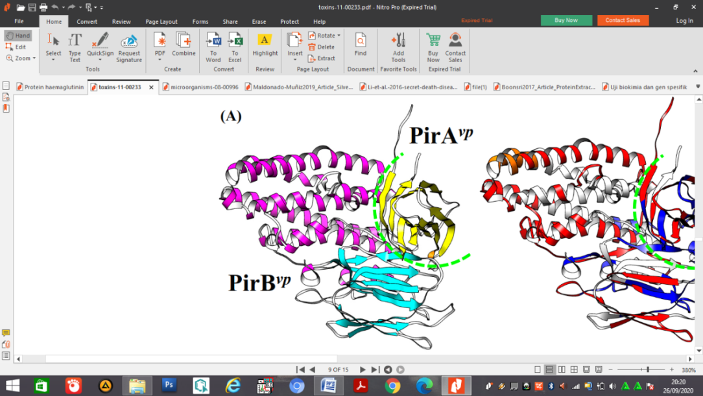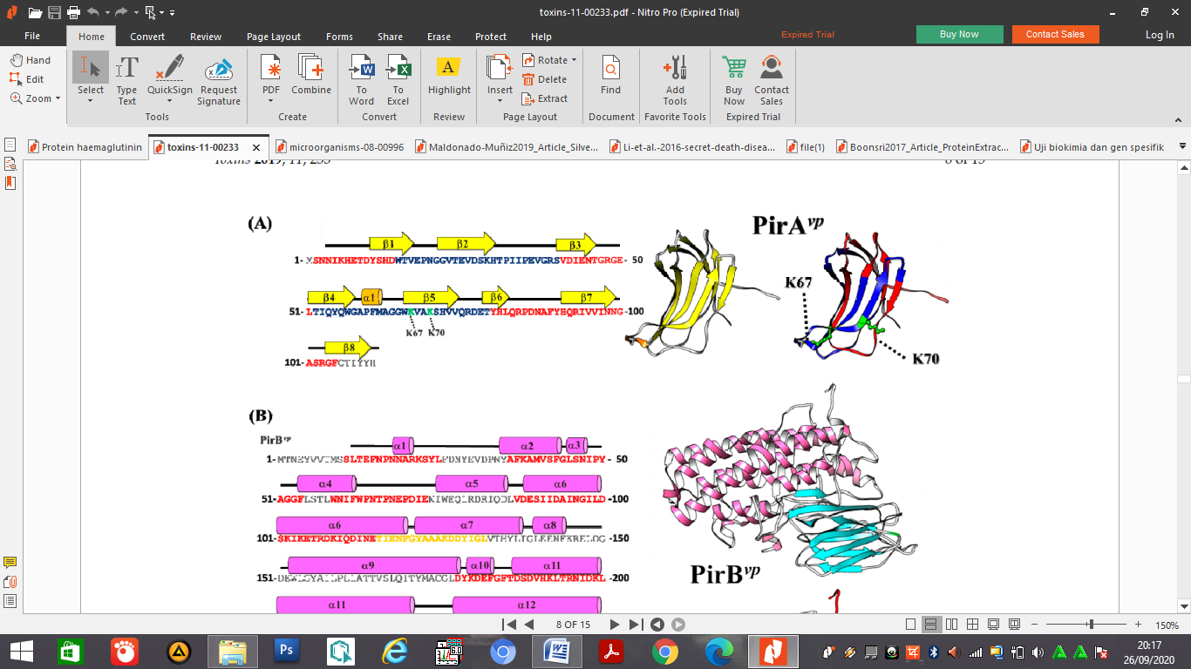

**Figure 1.** Structure of PirA and PirB in *Vibrio parahaemolyticus.*

PirAvp can participate in receptor recognition and binding. The PirAvp / PirBvp complex forms a high-order oligomer after binding to the receptor, PirBvp can be pulled towards the cell membrane, and PirAvp enters the membrane using the alpha-helix, thereby efficiently forming transmembrane pores. Stability can be increased after the PirA/PirB complex recognizes and interacts with its receptors (Lin et al., 2019). The mechanism for binding PirAvp / PirBvp with its receptors can be seen in Figure 2.

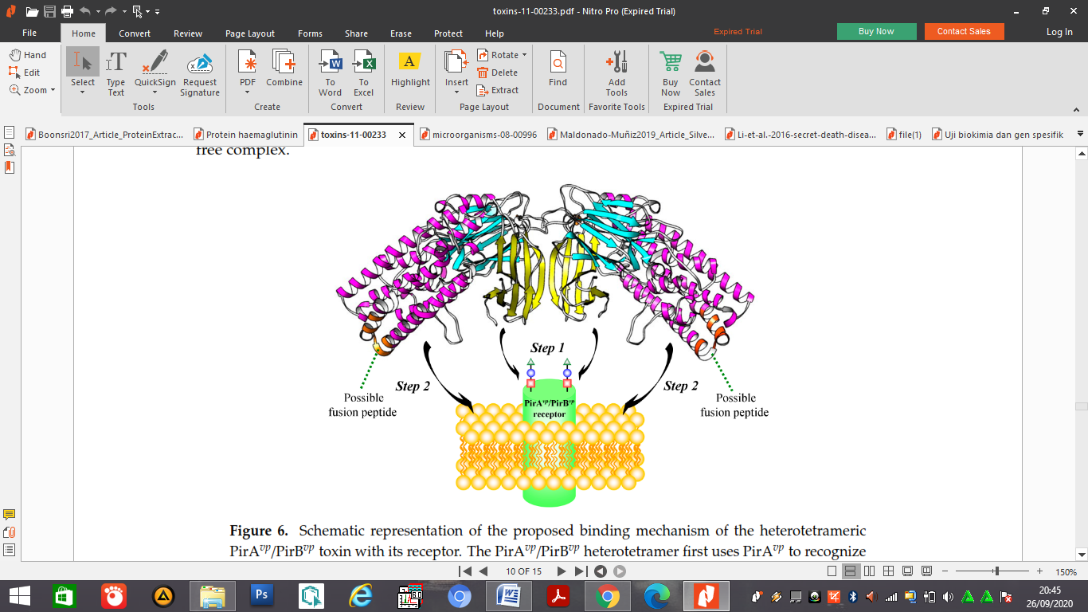

**Figure 2.** Schematic Representation of the Binding Mechanism of Heterotetrameric PirAvp and PirBvp Toxins with their Receptors (Lin et al., 2019).

1. **Vibriosis Diseases**

Vibriosis disease is one of the many diseases that often attack Asian sea bass cultivation. Vibriosis appears in fish caused by the bacteria *Vibrio* sp. which is also one of the most virulent types of bacteria attacking cultured marine fish. Some vibrio species are pathogenic and cause serious epizootic disease, but some species have opportunistic traits that can cause disease if the fish is physically injured or stressed. Diseases caused by the vibrio genus are also found in shrimp (Sarjito et al., 2007) and groupers (Sarjito et al., 2007; Sarjito et al., 2009). *Vibrio* is a type of bacteria that is facultative anaerobic. These bacteria can grow well in water with a temperature of 20-30oC and a pH of 4-9. Vibriosis has become a problem in marine, brackish fish (Irianto, 2005) and freshwater aquaculture (Austin and Austin, 2007; Sharma and Chaturvedi, 2007). In principle, the disease will be able to attack if there is an imbalance of the environment, host, and disease organisms. This unbalanced interaction can cause stress for fish, so that the fish's defense mechanism weakens and is susceptible to disease (Kordi, 2004). Apart from these three factors, fish diseases can attack due to low feed quality, poor quality of broodstock, non-optimal water conditions, inappropriate cultivation techniques, and contamination of the tools used (Chatter and Haldar, 2012).

Intensive aquaculture facilitates faster spread, so that it can cause a mortality of 85% (Guzma et al., 2001), one of the species that has a high virulence level is the bacteria *Vibrio parahaemolyticus* and *Vibrio vulnivicus* (Sugianto et al., 2017). Symptoms that occur in fish affected by vibriosis are lack of appetite, swimming sideways, pale gills, and wounds on the body surface and some fish die without any external clinical symptoms (Desrina et al, 2011). According to Mahardika and Indah (2013), the disease that often attacks Asian sea bass cultivation is vibriosis which can cause mass death in the larval and juvenile stages or fish with a size of 6-7 cm within 1-2 weeks after infection. Fitratunisa's research (2016) also revealed that the initial clinical symptoms of Asian sea bass seeds infected by *Vibrio* sp. experiencing anorexia, loss of appetite, loss of balance, and abnormal swimming behavior. While the morphological changes observed in this study were grazing on the dorsal fin, caudal fin, and opperculum as well as a blackened skin discoloration such as burning, causing death on the fourth day after infection and with a mortality rate of 90% within a week. Similar clinical symptoms have also been reported by Zaenuddin et al., (2019) which states that snapper is infected with the *Vibrio* sp. Bacteria. has ulcers on the body and rotten tail fin that runs out.

Vibriosis disease is very easily transmitted to other Asian sea bass because transmission can occur through water or direct contact between fish and the high density in aquaculture ponds. Containment and transmission can be prevented in several ways, such as strict application of biosecurity, use of antibiotics, administration of probiotics, and vaccinations. The use of antibiotics is often carried out in cultivation activities (Norviadi et al., 2010). However, the use of antibiotics is starting to be avoided because they have negative impacts such as residues on fish bodies, resistance to bacteria, causing pollution to the environment, and there are several countries that reject aquaculture products containing antibiotics (Soeripto, 2002). One solution that can be done is to use natural ingredients that contain antibacterial with the method of administration by injection or immersion.

1. **Handeuluem plant (*Graptophyllum pictum*)**

Handeuleum plants have long been known by the Indonesian people as medicinal plants, hedges, ornamental plants, and also wild plants. This plant has different names in each region such as demang (Java), handeuleum (Sundanese), dangora (Malay), friends (Bali), karaton (Madura) (Isnawati & Soediro, 2003), pudin (Simalur), kadi-kadi or kobi-kobi (Ternate), and dongo-dongo (Tidore) (Tukiran et al., 2014). Handeuleum leaf (*Graptophyllum pictum*) or by another name purple leaf / wungu is a medicinal plant that has been used by humans as herbal medicine because it has many properties, namely as a urinary laxative (diuretic), accelerates the ripening of boils, skin softener (emollient), anti-inflammatory, and antidiarrheal (Ummanah, 2017). Besides that, in addition to the leaves that are used as herbal medicine, the flowers can also be used as a menstrual facilitator (Dalimartha, 1999 in Ummanah, 2017).

The spread of the handeuleum plant is quite extensive, a plant originating from the Papua region which can also be found on other large islands in Indonesia such as Java, Maluku, and Ternate (Manoi, 2010). Handeuleum plants can grow in lowland areas up to 1,250 meters above sea level and can also grow in areas with dry or humid climates (Tukiran et al., 2014). In Lampung, handeuleum plants can be easily found and cultivated because they are commonly used as hedges and ornamental plants. The results of exploration on handeuleum plants in Pengalengan (West Java), Jayapura (Papua), and Maluku found that this plant has several types with a different appearance of leaf color patterns, namely leaves with purple, green leaves with a white hue in the middle, colored leaves. green with a white pattern on the edge of the green stem, green leaves with a white pattern on the edge of the stem brown and purple leaves with a white mark in the middle (Khumaida et al., 2008). The types of handeuleum leaves can be seen in Figure 3 below:

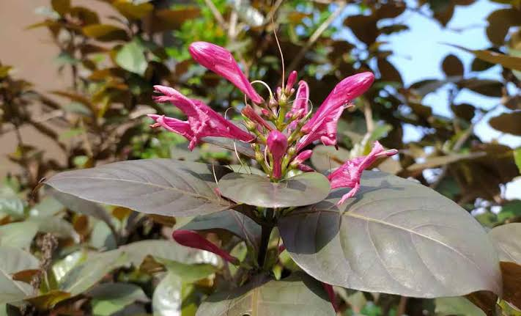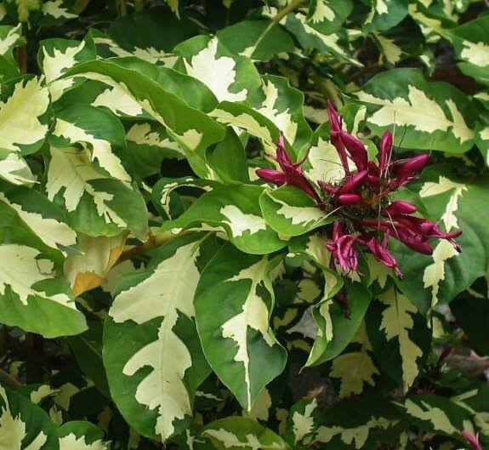

**2**

**1**

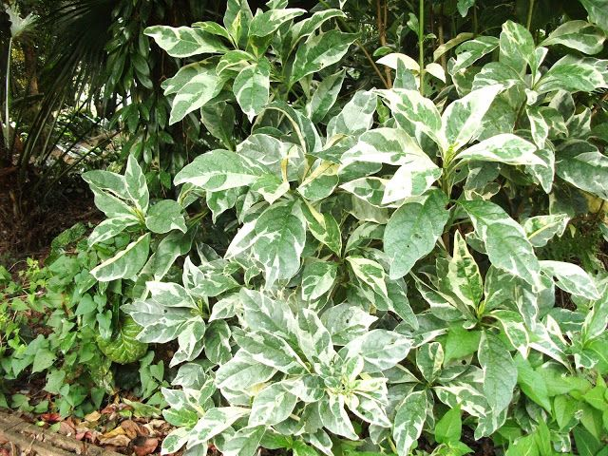

**3**

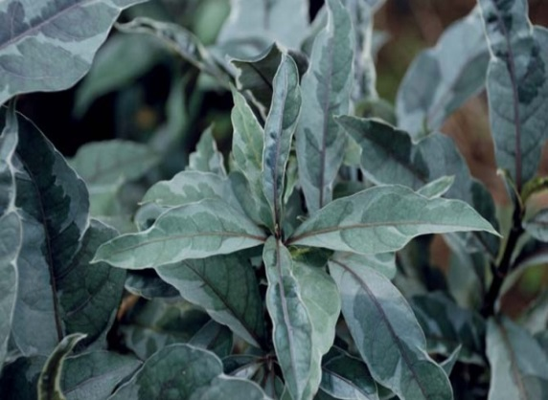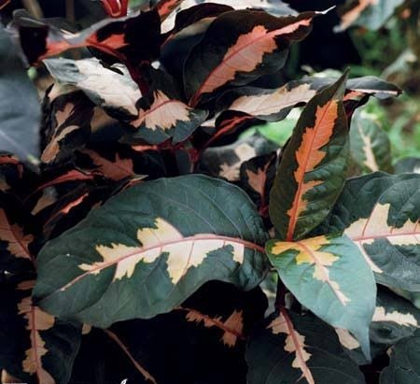

**5**

**4**

**Figure 3.** Types of handeuleum leaves. 1. Leaves with purple color, 2. Green leaves with white patterns in the middle, 3. Green leaves with white patterns on the edges and green stems, 4. Green leaves with white patterns on the edges and brown stems, 5. Leaves purple with white in the center.

This plant contains chemical compounds including non-toxic alkaloids, flavonoids, tannins, glycosids, steroids, saponins, calcium oxalate, formic acid, and fat (Tukiran et al., 2014). Alkaloids belong to the largest natural organic compound in terms of quantity and distribution. Alkaloids are defined as a group of compounds that are alkaline (alkaline) because they contain nitrogen atoms originating from plants and animals. Alkaloids in handeuleum leaves have the ability to be anti-inflammatory (anti-inflammatory) and as an analgesic (reduce pain) (Sya'haya & Iyos, 2016).

Flavonoids are the largest compounds of phenolic compounds, phenol compounds have inhibitory properties for the growth of viruses, bacteria, and fungi. Flavonoids work by denaturing proteins, with this process they can interfere with cell formation and result in changes in the composition of protein components (Mustarichie et al., 2011). When the cell membrane is disrupted, it will cause an increase in cell permeability and damage to bacterial cells which will then cause bacterial cell death. While tannins will act as growth inhibitors that will inhibit the growth of microorganisms and are compounds that can inhibit the synthesis of a bacterial cell wall and protein synthesis of Gram-positive and Gram-negative bacteria cells (Sya'haya & Iyos, 2016). The mechanism of tannins as antimicrobials goes through several stages, namely by inhibiting antimicrobial enzymes and inhibiting bacterial growth by reacting through cell membranes and deactivating essential enzymes or genetic material, then tannins form complexes with proteins through hydrophobic interactions that result in denaturation and disruption of cell metabolism in these microorganisms (Prabu et al., 2006).

Handeuleum leaf methanol extract has been proven to be effective in inhibiting the growth of *Enterococcus faecalis* bacteria, which is a bacteria in post-endodontic teeth (Azizah et al., 2013) and is also able to inhibit the growth of bacteria in the root canal with a minimum concentration of 12.5% ​​(Indriana et al., 2017). This methanol extract contains triterpenoids, glycosides, and saponins which can damage bacterial membrane proteins and thus inhibit the growth of these bacteria. Besides, the n-hexane, ethyl acetate, and water fractions from handeuleum leaves also have antibacterial activity on *Staphylococcus aureus* ATCC 25923 and *Escherichia coli* ATCC 25922 (Lely et al., 2017). Handeuleum leaf extract has also been shown to have antibacterial properties and is effective in inhibiting the growth of *Streptococcus mutans* (Rahman, 2017).

**d. Active Compounds in Handeuleum Leaves**

The active component in handeuleum leaves can be seen from the analysis using the GC-MS test. This test is a combination of the Gas Chromatography (GC) instrument and the Mass Spectrometry (MS) instrument. The working principle of GC is a mobile phase in the form of a gas flowing under pressure through a pipe that is heated and coated with a liquid stationary phase or packed with a liquid stationary phase overlaid on a solid support. Meanwhile, the principle of MS is the ionization of chemical compounds to produce charged molecules or molecular fragments and also measure the mass or charge ratio (Darmapatni et al., 2016). The results of the GC-MS test conducted by Manoi (2010) on handeuleum leaves found 21 active compounds, while research conducted by Budiaji et al., (2018) found 16 active ingredients components in handeulaum leaves. These compounds have a different percentage of content. The predictive identification of chemical compounds from handeuleum leaf extract can be seen in Tables 1 and 2 below.

**Table 1.** Identification of Predicted Chemical Compounds from Handeuleum Leaf Extract According to Manoi (2010).

|  |  |  |
| --- | --- | --- |
| No. | Compounds | Percentage (%) |
| 1 | Hexadeconoic acid, Palmitit | 20,51 |
| 2 | 24.XI.-Ethylcolest-5-en-3.beta.-O | 10,93 |
| 3 | Dodecanoic acid (Lauric acid) | 8,17 |
| 4 | 9,17-Octadicadienal, (Z) - (CAS) | 6,34 |
| 5 | 2-Hexadecen-1-ol,3,7,11,15-tetram | 5,84 |
| 6 | Neophytadiene | 5,43 |
| 7 | Tetradecanoic acid (myrist) | 5,02 |
| 8 | Stigmasta-5,23-dien-3,beta,-ol | 4,90 |
| 9 | 2,6,10,14,18,22-Tetracosahexaene | 3,81 |
| 10 | Hexadecanoic acid, methyl ester | 2,81 |
| 11 | Gamma tocopherol | 2,33 |
| 12 | Vitamin E | 2,12 |
| 13 | Cycloeucalenol | 1,90 |
| 14 | 9,12,15-Octadecatrienoic acid | 1,86 |
| 15 | 23,24-Bisnorchola-5,17 (20)-dien-3 | 1,36 |
| 16 | 2-hexedecene,3,7,11,15-tetramethyl | 1,26 |
| 17 | D-Hexadecene,3,7,11,15-tetrametyl | 1,23 |
| 18 | Bendzo(b)furan-6-carboxaldehyde | 1,16 |
| 19 | 17.alpha-Acetoxy-3.beta.,-19-epoxy | 1,09 |
| 20 | Hexadecanoic acid, palmitit | 1,07 |
| 21 | 2,3-Dihydro-benzofuran | 0,92 |

**Table 2.** Identification of Predicted Chemical Compounds from Handeuleum Leaf Extract According to Budiaji et al., (2018)

|  |  |  |
| --- | --- | --- |
| No. | Compounds | Percentage (%) |
|
| 1 | (23) - etylcholes- 5-en-3.beta.-ol | 18,09 |
| 2 | 9,12,15-Octadecatrienoic acid | 12,58 |
| 3 | Stigmasta-5,22-dien-3-ol (3.beta.) | 11,11 |
| 4 | Neophytadiene | 7,17 |
| 5 | Hexadecanoic acid (palmitid) | 7,55 |
| 6 | 2-Hexadecen-1-ol, 3,7,11,15-tetram | 5,96 |
| 7 | Vitamin E | 4,20 |
| 8 | 2-Hexadecene,3,7,11,15-tetramethyl | 2,40 |
| 9 | Ergos-5-en-3-ol (3.beta.) | 2,02 |
| 10 | Gamma tocopherol | 1,86 |
| 11 | 1-Hexadecanaminium, N, N, N-trimethyl | 1,85 |
| 12 | Cycloeucalenol | 1,81 |
| 13 | Octadeconoic acid | 1,78 |
| 14 | 2,6,10,14,18,22-Tetracosahexaene | 1,47 |
| 15 | Hexadecanoid acid, methyl ester | 1,47 |
| 16 | Norolean-12-ENE | 1,18 |

The results of the GC-MS test conducted by Manoi (2010) and Budiaji et al., (2018) can be concluded that in the handeuleum leaf extract there are 25 active compounds because it was found that there were some similarities in the compounds in these two studies. The results of this test were then carried out further tests using the Pubchem online website and PassOnline to determine the structure and biological activity of each of these compounds. The structure of the compounds in handeuleum leaves can be seen in Figures 4, 5, 6, 7, 8, 9, 10, 11, 12, 13, 14, 15, 16, 17 below.

1. *Hexadecanoic acid* (*palmitic acid*)

This compound has the IUPAC name hexadecanoic acid. Other names for this compound are palmitic acid, cetylic acid, palmitate, n-hexadecanoic acid, and hexaectylic acid. The chemical structure of the hexadecanoic acid compound is as follows:

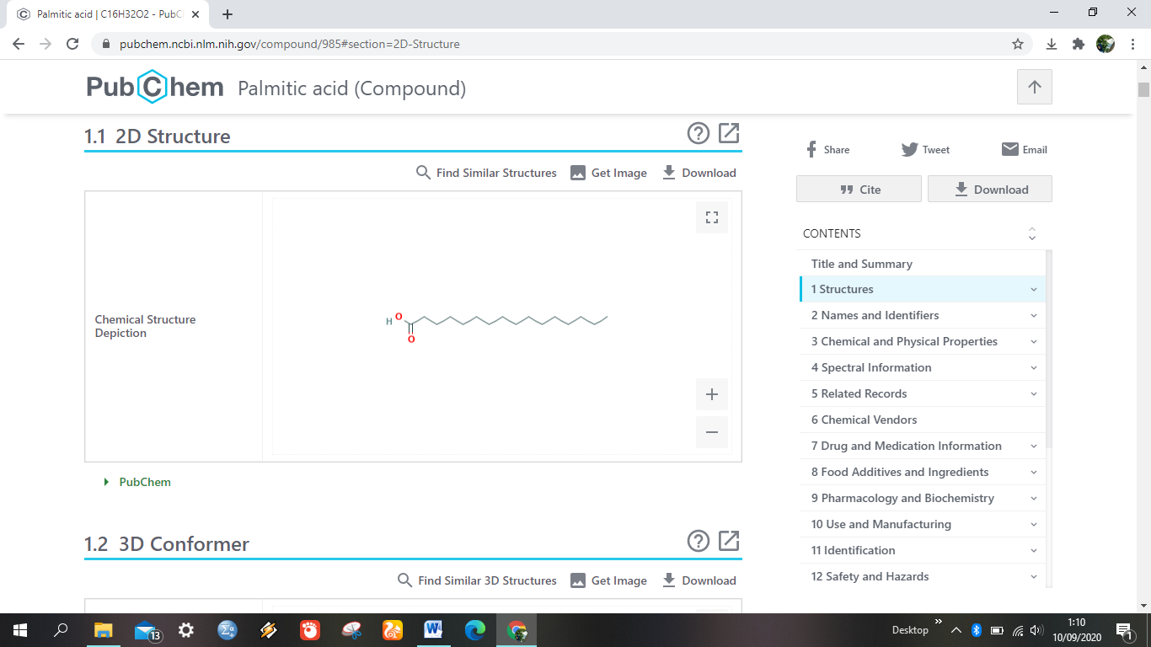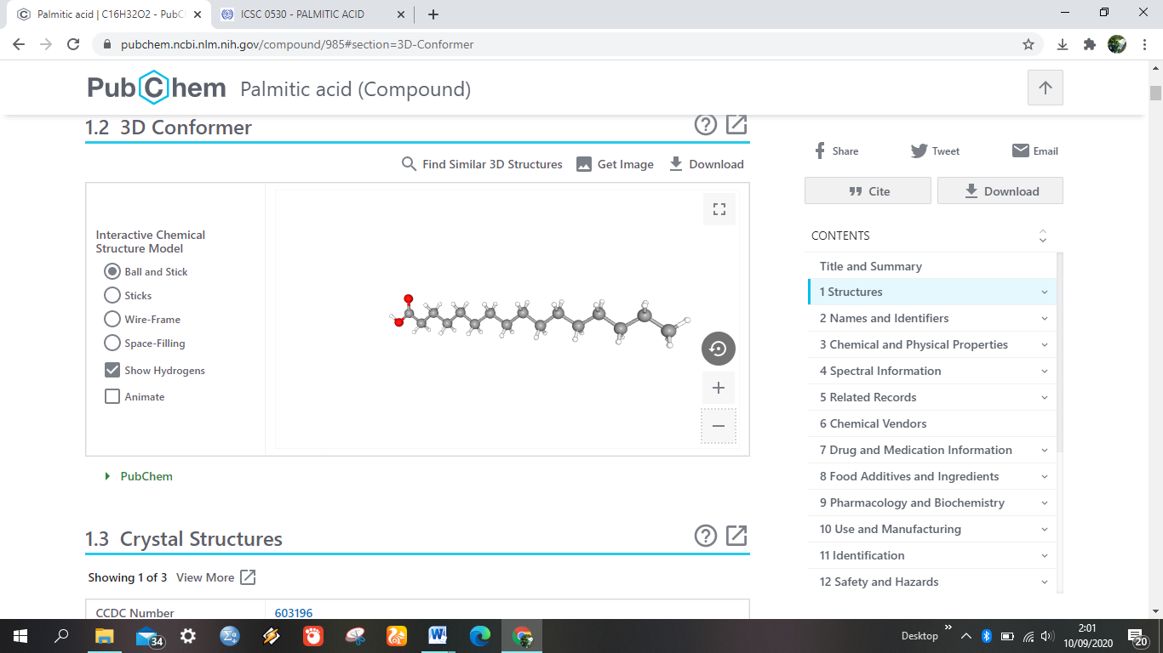

**Figure 4.** Chemical Structure of Hexadecanoic Acid

2. *24.XI.Ethylcholest-5-en-3beta-ol*

This compound has other names stigmast-5-en-3-ol, 24-ethylcholestrol, 3beta-sitosterol, 5-stigmasta-3 beta-ol, and 3beta-stigmast-5-en-3-ol. The chemical structure of 24-ethylcholest-5-en-3beta-ol is as follows:

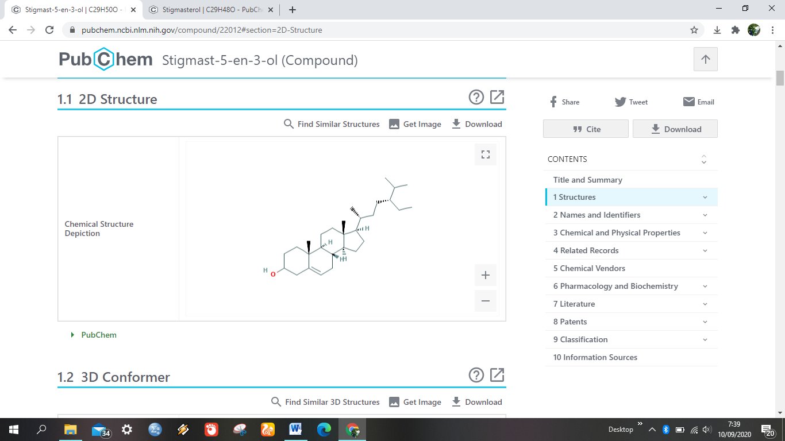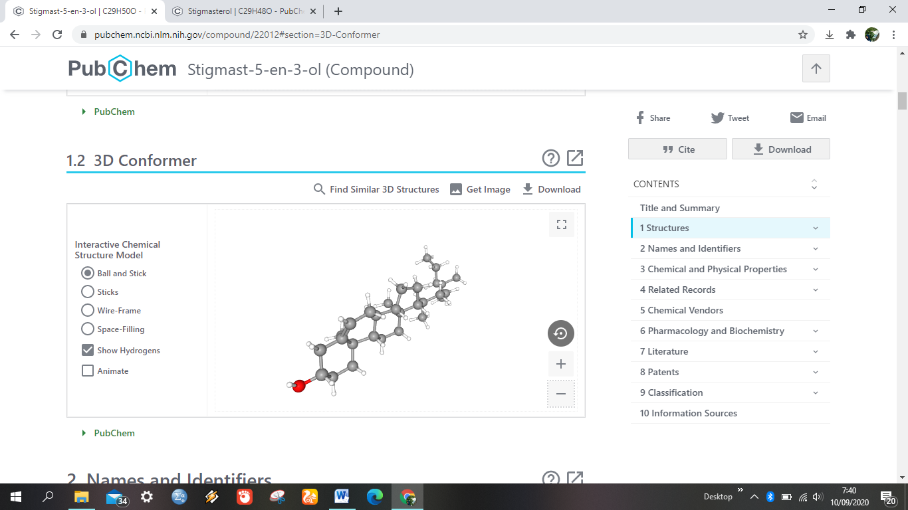

**Figure 5.** Chemical Structure of *24.XI.Ethylcholest-5-en-3beta-ol*

3. *9,12,15-Octadecatrienoic acid*

9,12,15-octadecatrienoic acid has the name IUPAC octadeca-9,12,15-trienoic acid and its other names are 9,12,15-octadecatrienoic acid, (9Z, 12Z, 15Z) -AK106170, and 9,12 , 15-octadecatrienoicacid. The chemical structure of 9,12,15-octadecatrienoic acid is as follows:

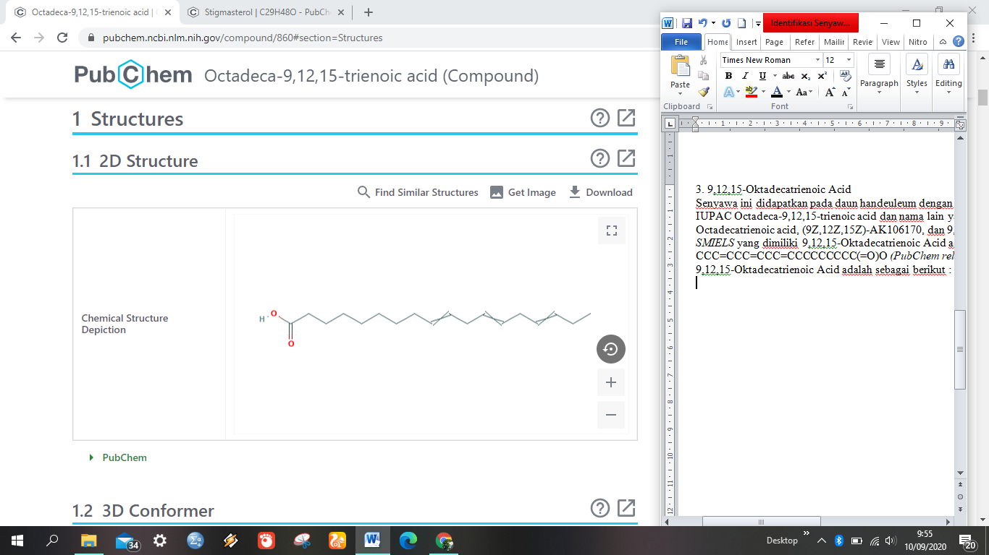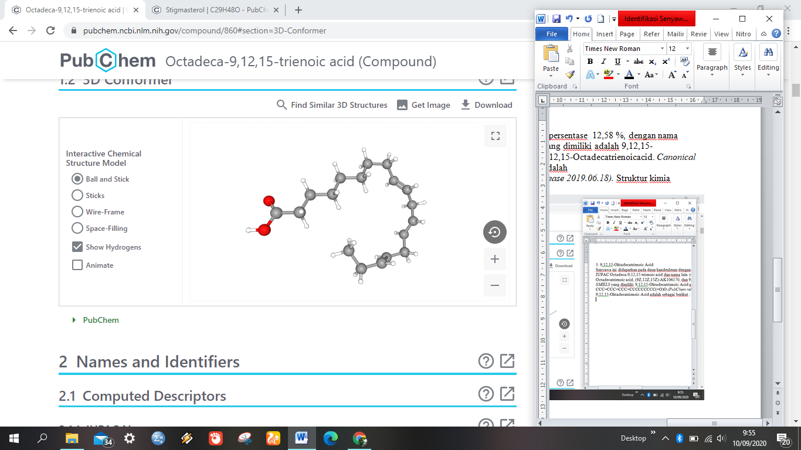

**Figure 6.** Chemical Structure 3. *9,12,15-Octadecatrienoic Acid*

4. Stigmasta-5,22-dien-3-ol

The compound of stigmasta-5,22-dien-3-ol has the IUPAC name (3S, 8S, 9S, 10R, 13R, 14S, 17R) -17 - ((E, 2R, 5S) -5-ethyl-6-methylhept -3-en-2-yl] -10,13-dimethyl-2,3,4,7,8,9,11,12,14,15,16,17-dodecahydro-1H-cyclopenta [a] phenanthren- 3-ol and other names are stigmasterol, stigmasterin, beta-stigmasterol, stigmasta-5,22-dien-3beta-ol and stigmasta-5,22E-dien-3beta-ol. The chemical structure of stigmasta-5,22-dien-3-ol is as follows:

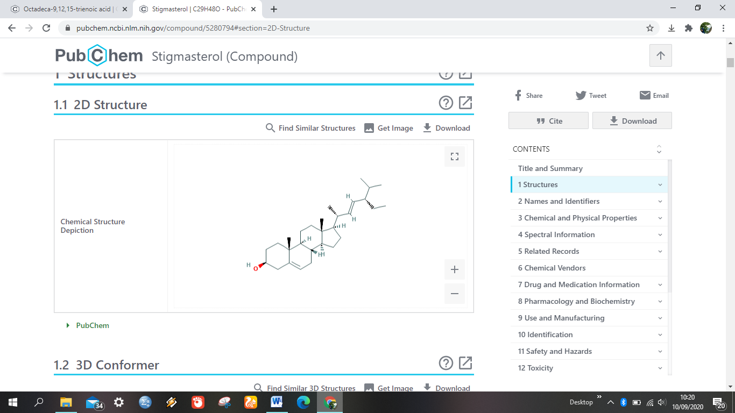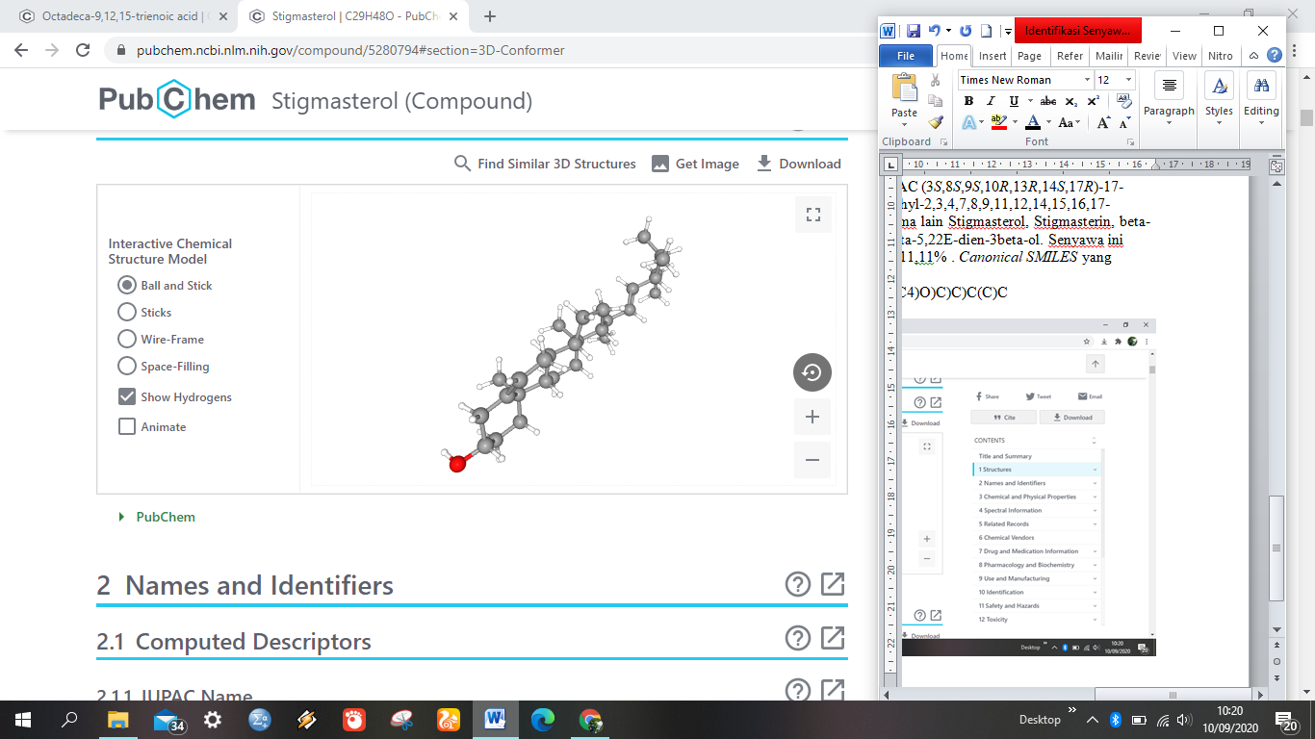

**Figure 7.** Chemical Structure of Stigmasta-5,22-dien-3-ol

5. Dodecanoid acid

The IUPAC name of this compound is dodecanoic acid and other names are lauric acid, n-dodecanoid acid, dodecylic acid, vulvic acid, dodecoic acid, and duodecylic acid. The chemical structure of this compound is as follows:

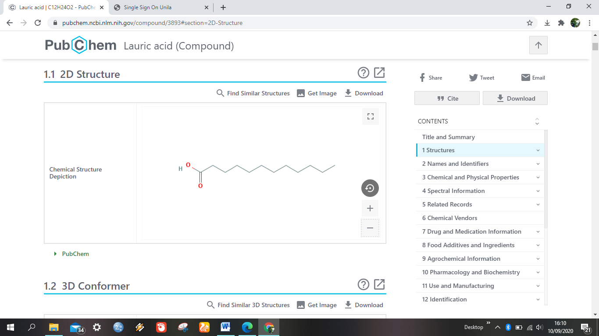

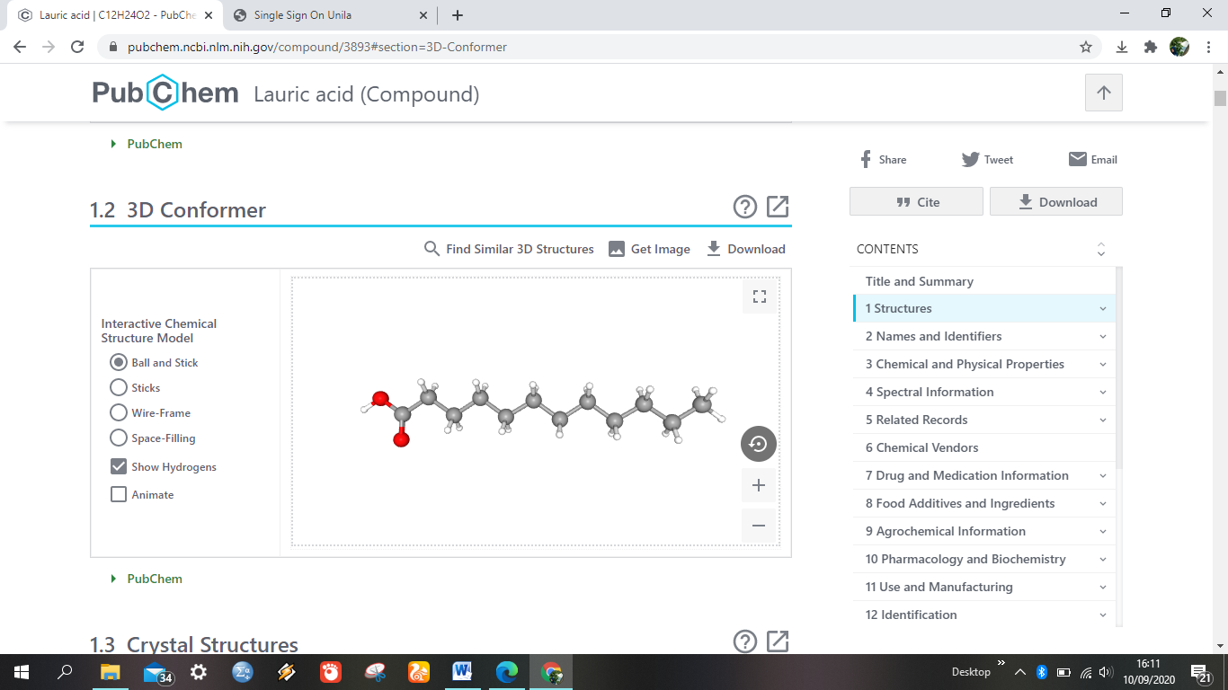

**Figure 8.** Chemical Structure of Dodeconoid Acid

6.17-octadecadienal, (Z) - (CAS)

The compound of 9,17-octadecadienal, (Z) - (CAS) was found in handeuleum leaves with a percentage of 6.34%. other names of this compound are (z) -9,17-octadecadienal, 9,17-octadecadienal, (Z) -56554-35-9, (9Z) -9,17-octadecadienal, and 9,17-octadecadienal (Z ) SCEMBL3966133. The chemical structure of 9,17-octadecadienal, (Z) - (CAS) is as follows:

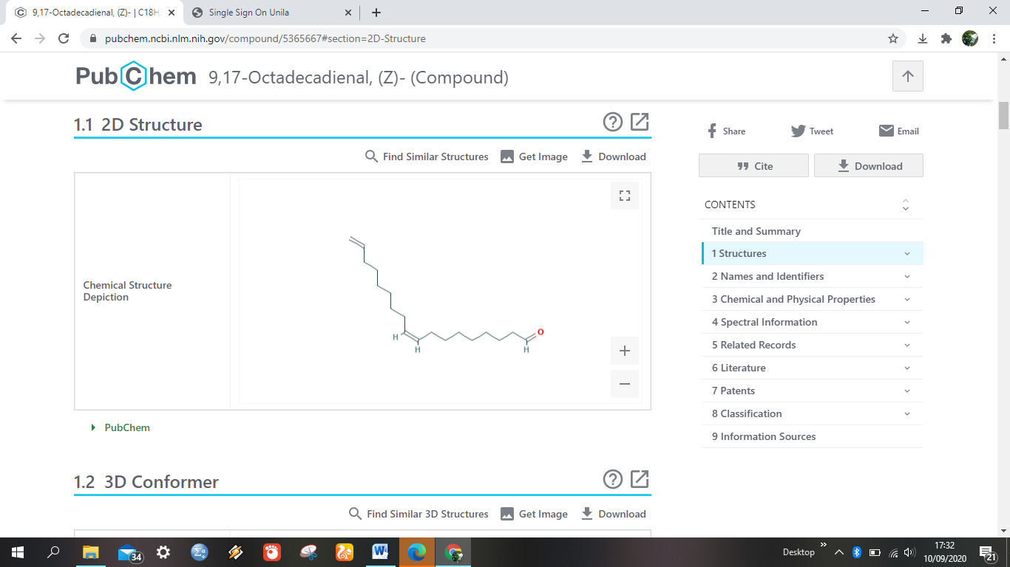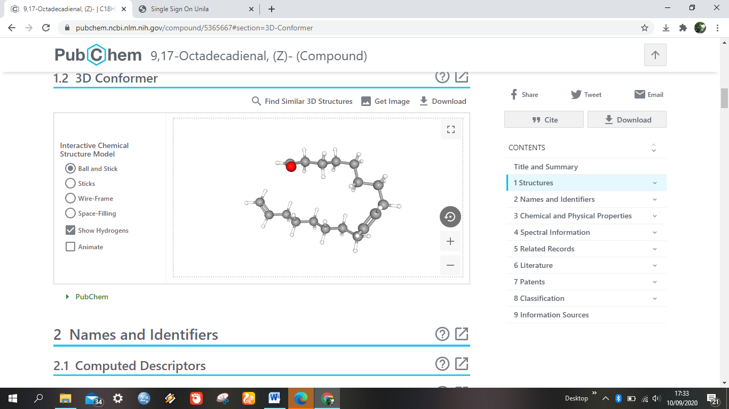

**Figure 9.**Chemical Structure of 9,17-Octadecadienal, (Z) - (CAS)

7. Neophytadiene

The IUPAC name of this compound is 7,11,15-trimethyl-3-methylidenehexadec-1-ene, this compound has an anti-inflammatory, anti-microbial role, as a metabolite of algae and plants. Neophytadiene compounds are found in handeuleum leaves with a percentage of 5.43%. Other names for this compound are 1-hexadecene, 7,11,15-trimethyl-methylene, 2- (8,12-trimethyltridecyl) blind-1,3-diene, and UNII-HL3QFB56FB. The chemical structure of the neophytadiene compound is as follows:

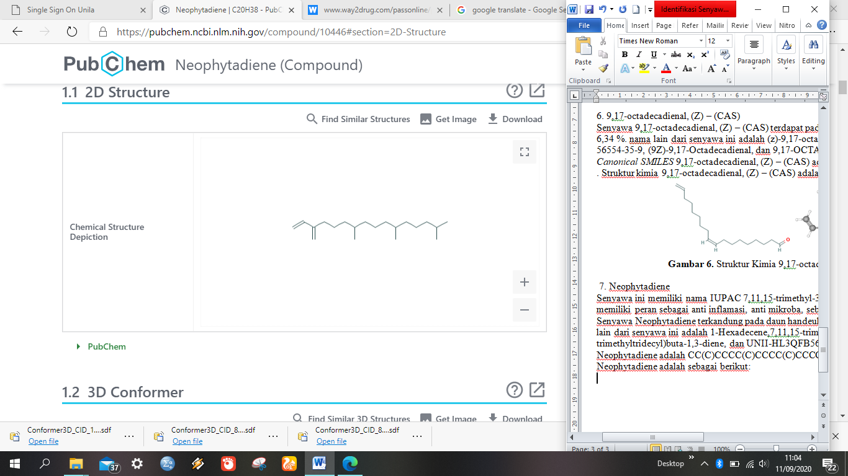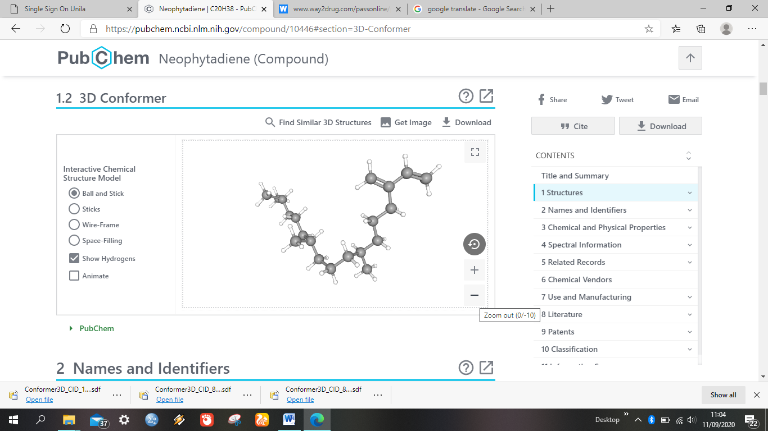

**Figure 10.** Chemical Structure of Neophytadiene

8. Tetradecanoic acid

The IUPAC name of this compound is tetradecanoic acid and other names are myristic acid, n-tetradecanoic acid, crodacid, n-tetradecoic acid, and n-tetradecan-1-oicacid. The chemical structure of this compound is as follows:

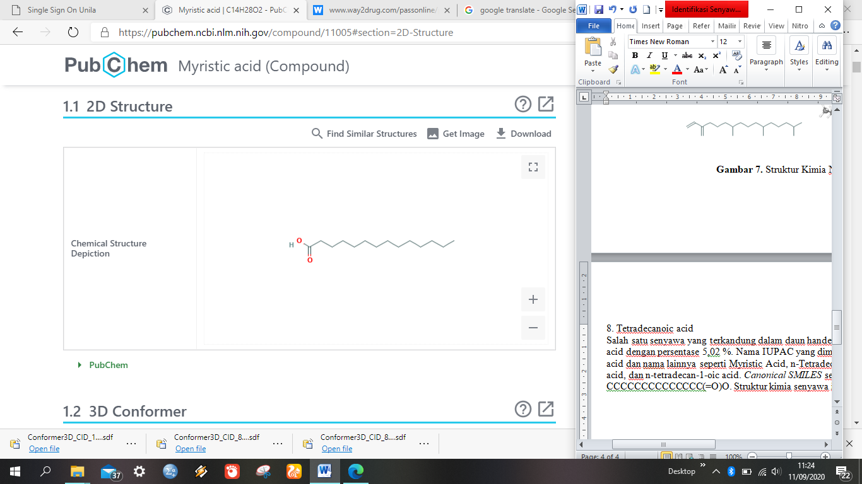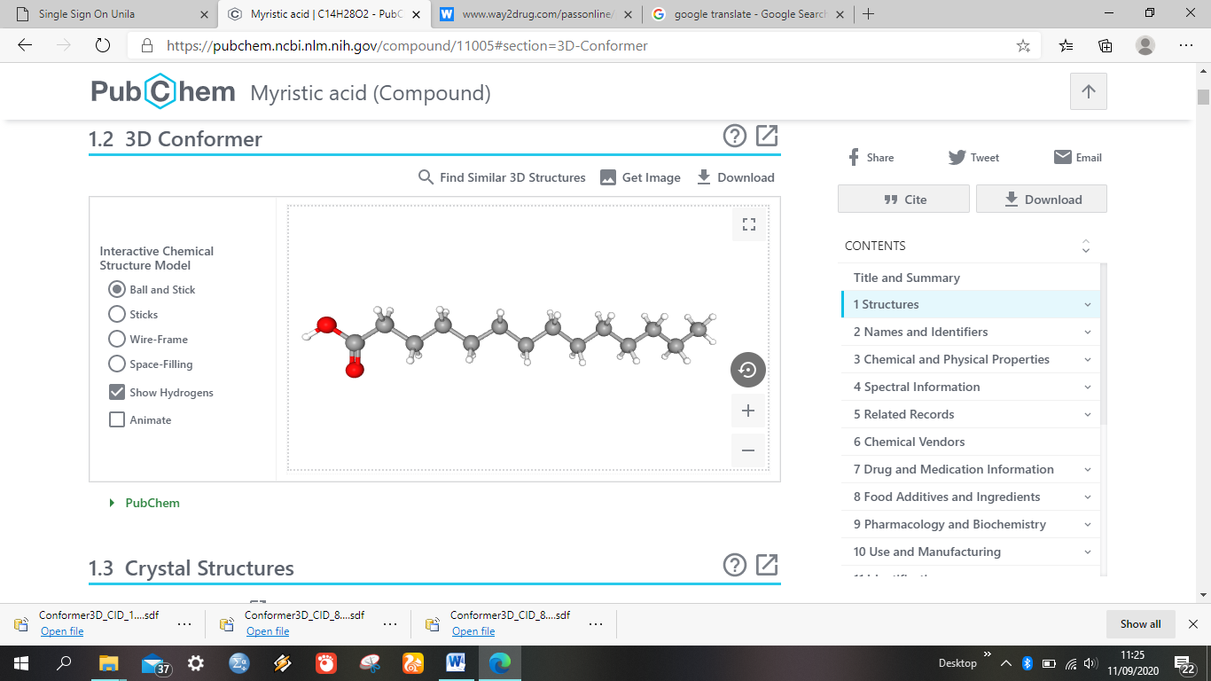

**Figure 11.** Chemical Structure of Tetradecanoic Acid

9. Gamma tocopherol

The IUPAC name of this compound is (2R) -2,7,8-trimethyl-2 - [(4R, 8R) -4,8,12-trimethyltridecyl] -3,4-dihydrochromen-6-ol and other names of the compound. this is D-gamma-tocophe, (+) - gamma-tocopherol, and gamma-tocopherol, d-, RRR-gamma-tocopherol. Gamma-tocopherol compounds are contained in handeuleum leaves with a percentage of 2.33%. The chemical structure of gamma tocopherol is as follows:

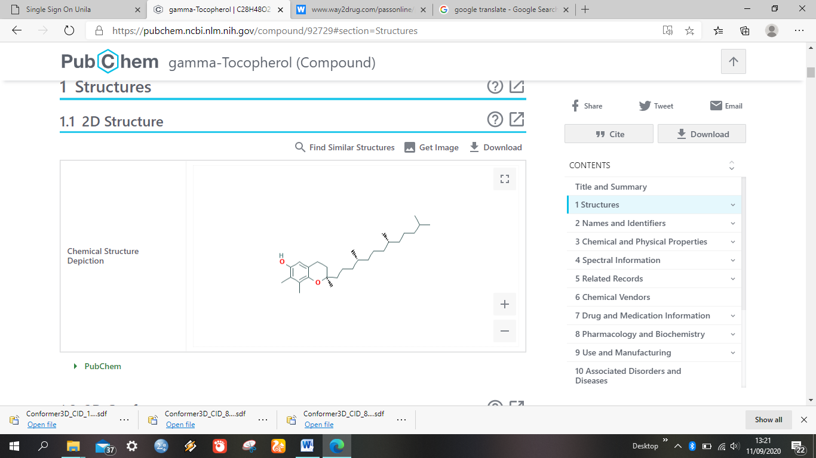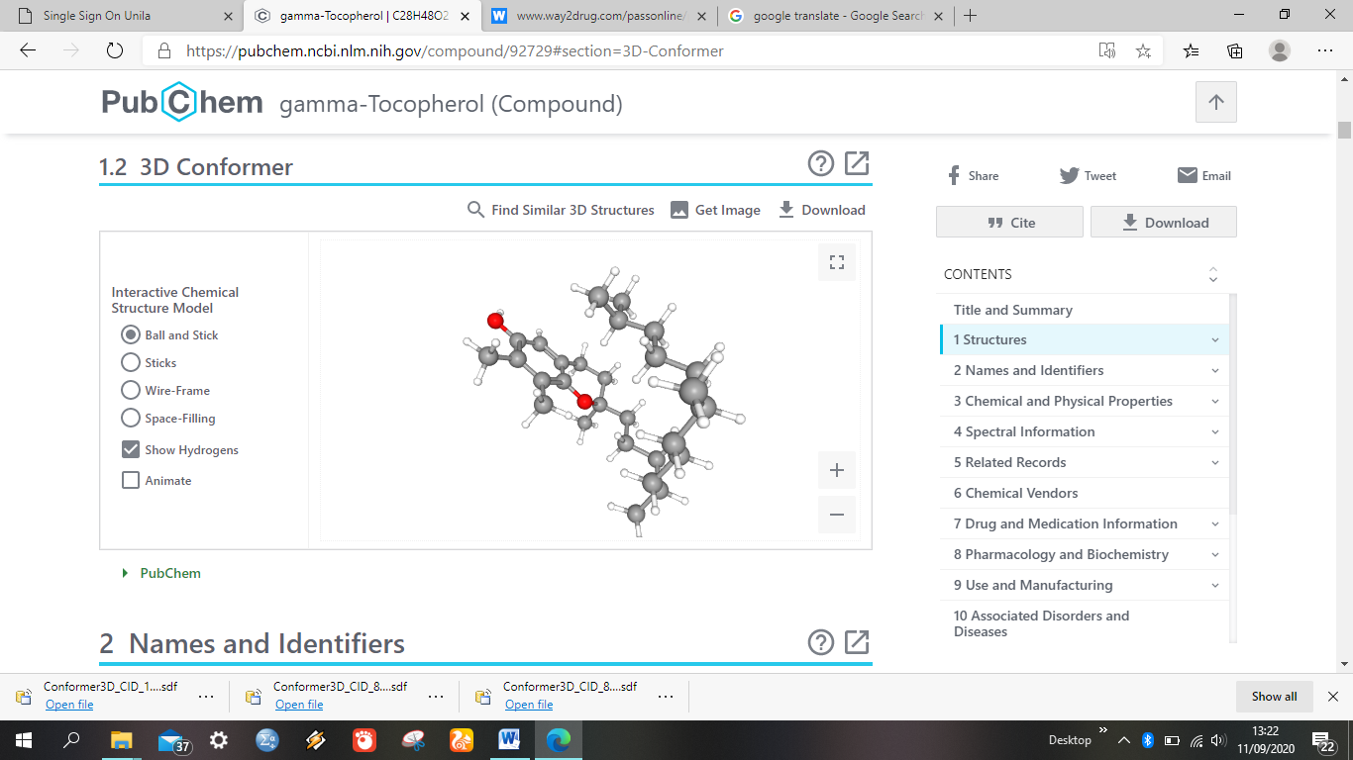

**Figure 12.** Chemical Structure of Gamma Tocopherol

10. *Hexadecanoic acid* (*methyl ester*)

This compound has the IUPAC name methyl hexadecanoate and other names are methyl palmitate, methyl hexadecanoate, palmitic acid methyl ester, and Unipaht 2216. hexadecanoic acid (methyl ester) is a compound found in handeuleum leaves with a percentage of 2.81%. The chemical structure of the compound hexadecanoic acid (methyl ester) can be seen in Figure 12.

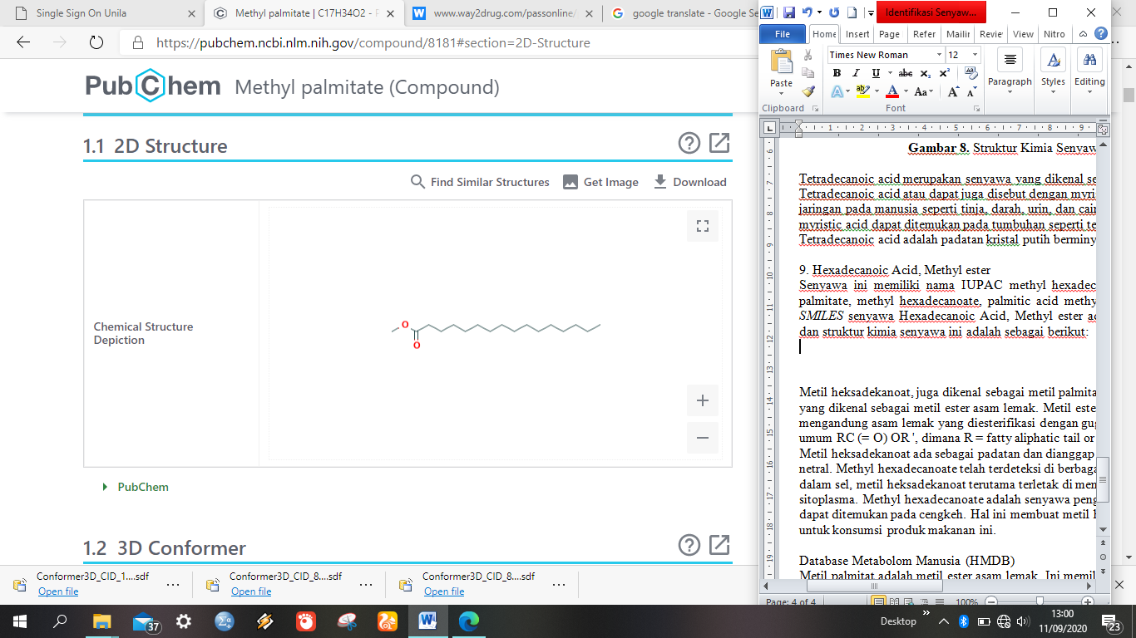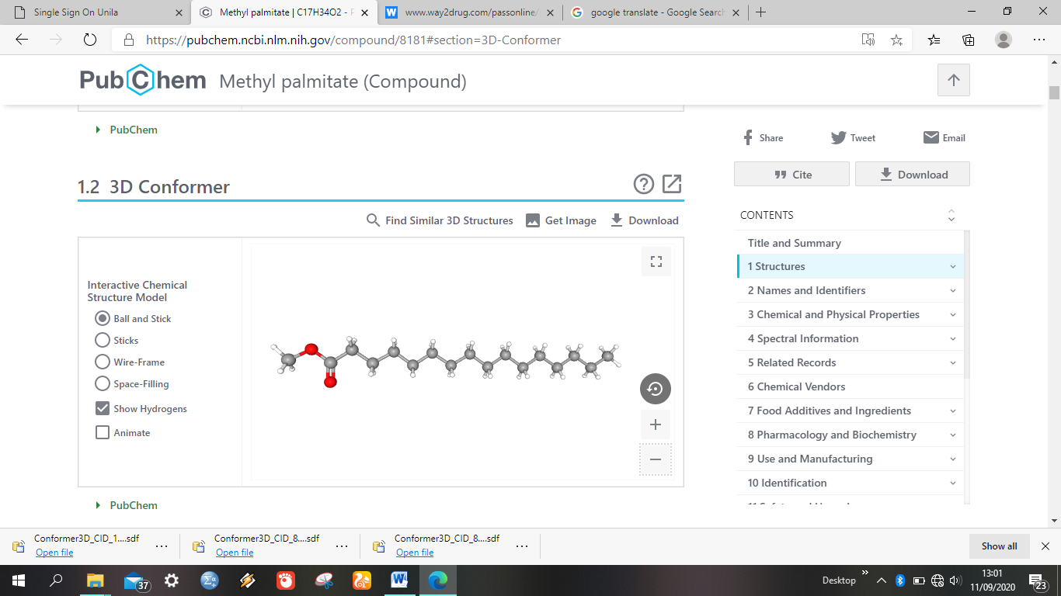

**Figure 13.** Chemical Structure of Hexadecanoic Acid Compounds (Methyl Ester)

11. Vitamin E

Vitamin E is a fat-soluble vitamin and has a role in protecting cells from oxidative stress, and can regulate immune function. This compound has the IUPAC name (2R) -2,5,7,8-tetramethyl-2 - [(4R, 8R) -4,8,12-trimethyltridecyl] -3,4-dihydrochromen-6-ol and has other names such as alpha-tocopherol, D-alpha-tocopherol, 5,7,8-Trimethyltocol, alpha-vitamin E and aquasol E. The chemical structure of vitamin E compounds can be seen in Figure 14.

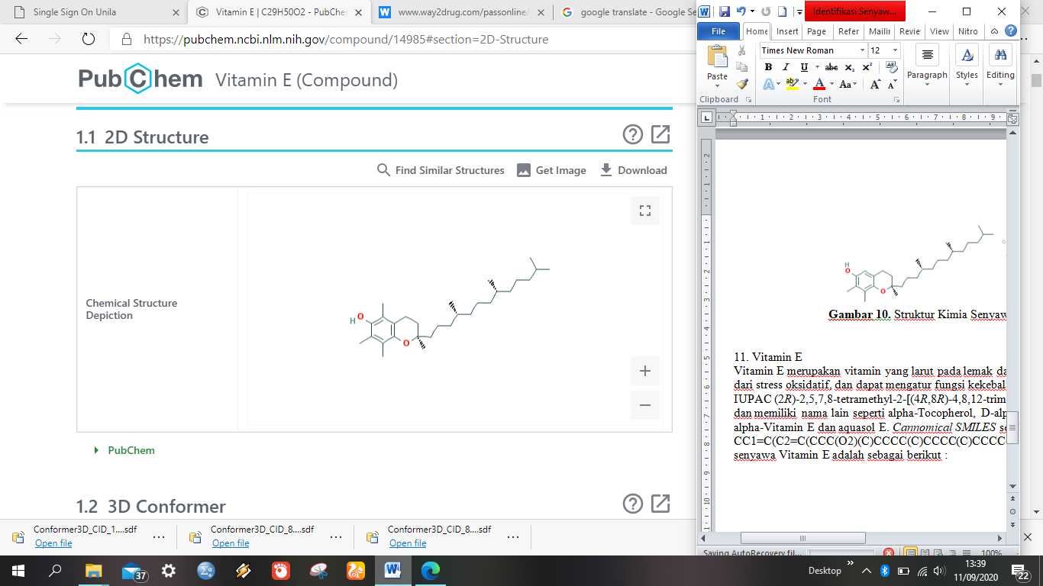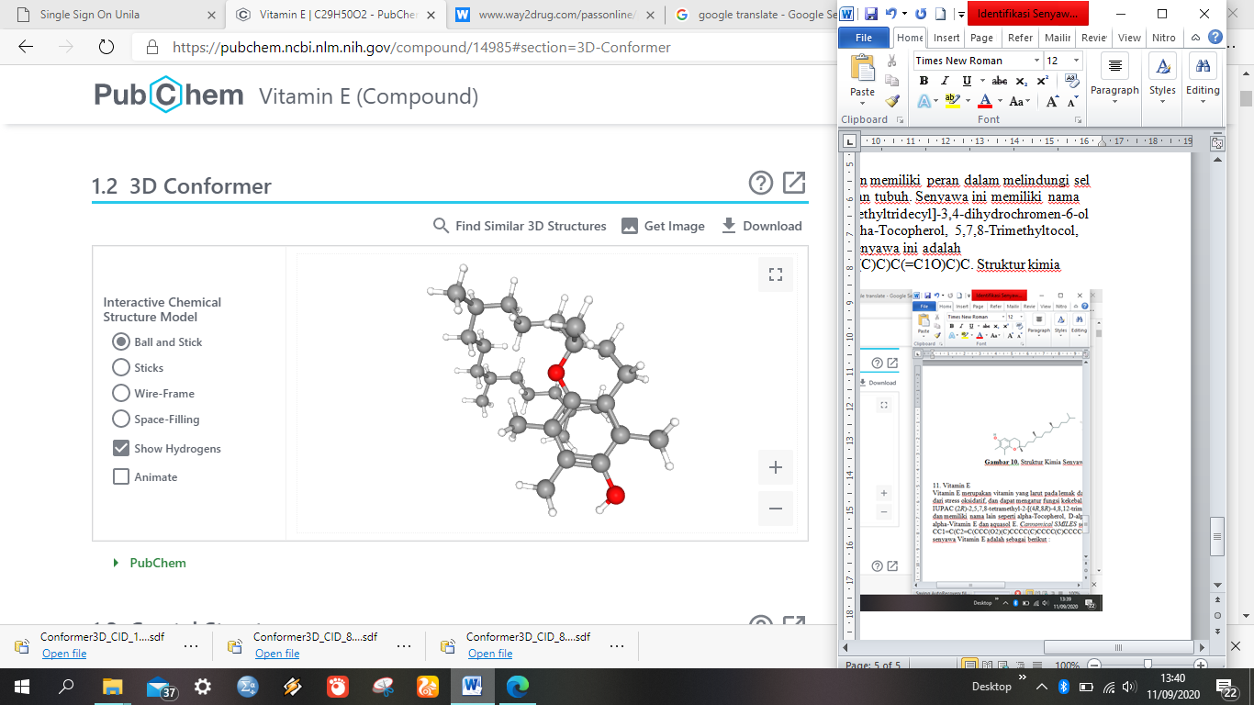

**Figure 14.** Vitamin E

12. Cycloeucalenol

This compound has the IUPAC name (1S, 3R, 6S, 7S, 8S, 11S, 12S, 15R, 16R) -7,12,16-trimethyl-15 - ((2R) -6-methyl-5-methylideneheptan-2- yl] pentacyclo [9.7.0.01,3.03,8.012,16] octadecan-6-ol. Other names that this compound has are UNII-7OF1Q9UE9R, 4alpha, 14-dimethyl-9beta, 19-cyclo-5alpha-ergost-24 (28) -en-3beta-ol, and 3beta, 4alpha, 5alpha-4,14-dimethyl -9,19-cycloergost-24 (28) -en-3-ol. The chemical structure of this compound can be seen in Figure 15.

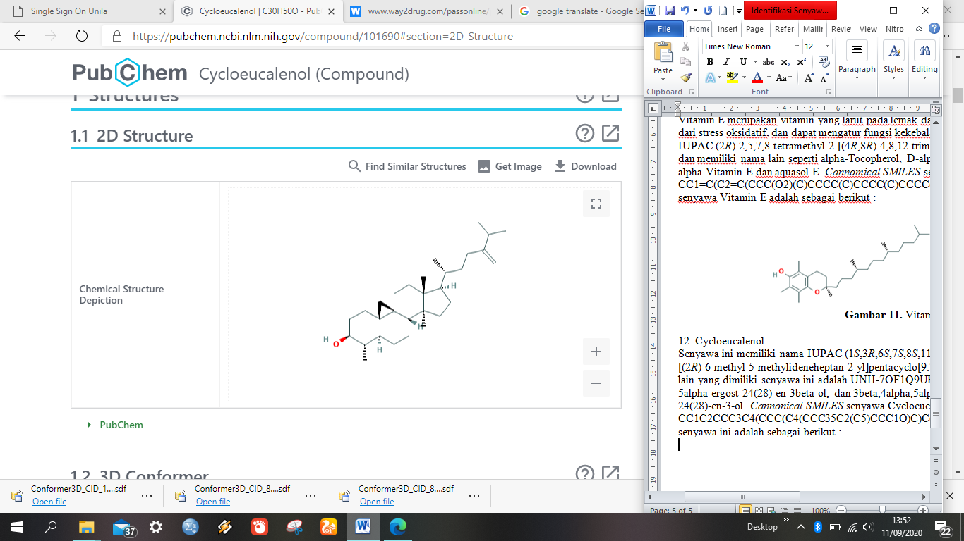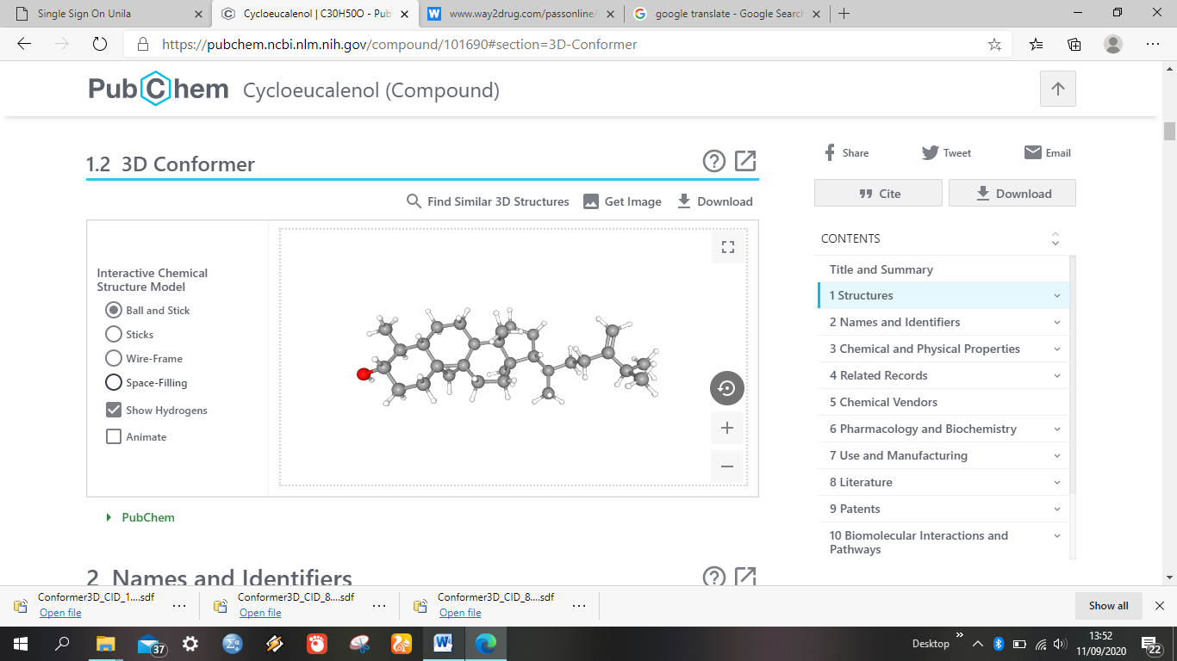

**Figure 15.** Chemical Structure of Cycloeucalenol Compounds

13. 2,3-dihydro-benzofuran

The 2,3-Dihydro-benzofuran compound has IUPAC 2,3-dihydro-1-benzofuran and another name for this compound is coumaran, 2,3-dihydrobenzo [b] furan, 2,3-dihydro-1-benzofuran, dihydrobenzofuran, and dirty. The chemical structure of this compound can be seen in Figure 16.

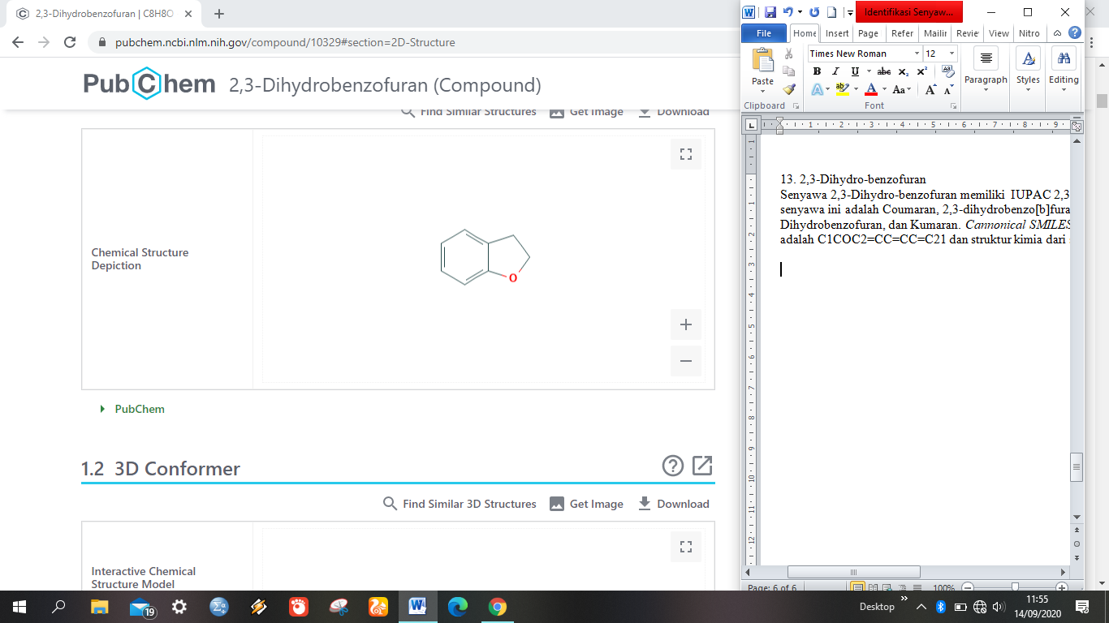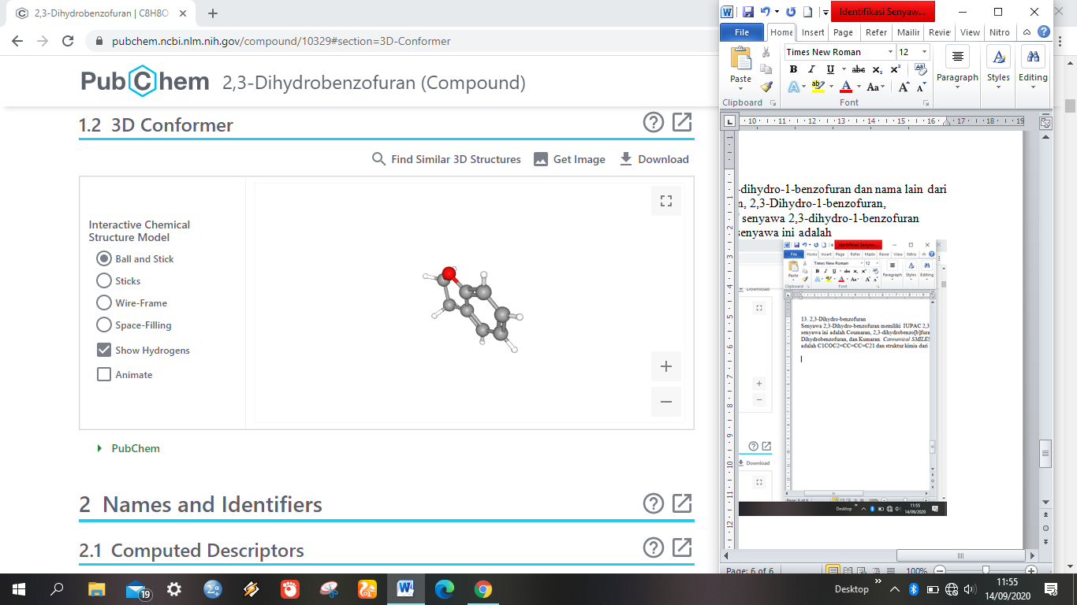

**Figure 16.** Chemical Structure of 2,3-dihydro-1-benzofuran compounds

14. *Octadecanoic acid*

This compound has the name IUPAC octadecanoic acid and has other names such as stearic acid, stearophanic acid, n-octadecanoic acid, cetylacetic acid, pearl stearic, stearex beads, octadecansaeure, stearinsaeure, vanicol, 1-heptadecanecarboxylic acid, and century 1240. octadecanoic acid can be seen in Figure 17.

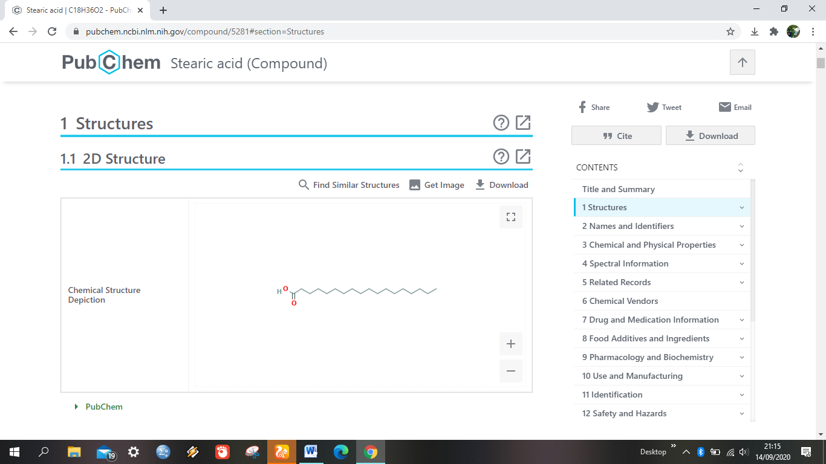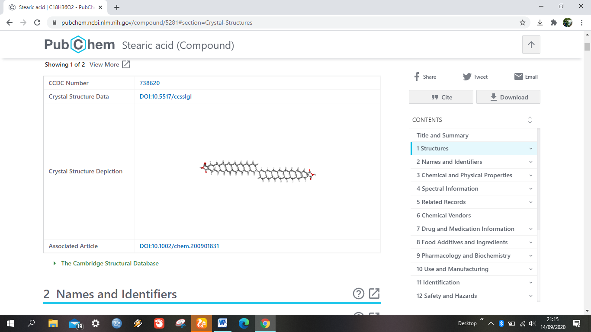

**Figure 17.** Chemical Structure of Octadecanoid Acid Compounds

**e. Potential of Handeuleum Leaves as Antibacterial**

Bioactivity analysis was carried out on 14 compounds because the structure of the other compounds was not found on the Pubchem website. Then, bioactivity analysis was carried out on these 14 compounds using the PassOnline website. This online website can be used to determine the biological activity of each compound, especially the antibacterial activity. Analysis using PassOnline provides a predictive value based on the value of Pa (Probability activity) and Pi value (Probability inactivity). According to IIOB (2016) the higher Pa value indicates the biological activity is more accurate when tested on organisms directly or in the laboratory. Analysis of the antibacterial activity of compounds on handeuleum leaves is presented in Table 3 below.

**Table 3.** Analysis of Antibacterial compounds on Handeuleum leaves

|  |  |  |  |
| --- | --- | --- | --- |
| No. | compounds | biological activity | Pa value |
| 1 | 9,17-Octadicadienal, (Z) - (CAS) | Antimycobacterial | 0,437 |
| 2 | Cycloeucalenol | Antibacterial | 0,387 |
| 3 | Neophytadiene | Antibacterial | 0,363 |
| 4 | Hexadeconoic acid (Palmitit acid) | Antituberculosic | 0,362 |
| 5 | Tetradecanoic acid (Myristic acid) | Antituberculosic | 0,362 |
| 6 | Octadeconoic acid | Antituberculosic | 0,362 |
| 7 | Dodecanoic acid (Lauric acid) | Antimycobacterial | 0,349 |
| 8 | Hexadecanoic acid (Methyl ester) | Antimycobacterial | 0,321 |
| 9 | Stigmasta-5,22-dien-3-ol (3.beta.) | Antibacterial | 0,300 |
| 10 | Vitamin E | Antibacterial | 0,214 |
| 11 | Gamma tocopherol | Antibacterial | 0,211 |
| 12 | 2,3-Dihydro-benzofuran | Antibacterial | 0,186 |
| 13 | 9,12,15-Octadecatrienoic acid | Antibacterial | 0,164 |
| 14 | 24.XI.-Ethylcolest-5-en-3.beta.-O | - | - |

The computational approach uses the insilico test by Rahmaningsih and Andriani (2016) on majapahit leaves to *Vibrio harveyi* bacteria, it is said that the hexadecanoic acid (palmitit acid) compound has an antibacterial mechanism against *Vibrio harveyi* bacteria. In addition, laboratory reserch have been conducted by Melki et al., (2011) reporting that palmitic acid in *Glacilaria* sp. has the ability as an inhibitor of *E. coli* (14.33 mm) and *S. aureus* (12.67 mm). Krishnan et al., (2016) added the hexadecanoic acid (palmititic acid) in the *Canthium palviflorum* leaf extract was effective in inhibiting *Staphylococcus aureus*, *Escherichia coli*, *Bacillus subtilis*, and *Candida albicans* significantly. Jegadeeswari et al., (2012) stated hexadecanoic acid compounds not only have antibacterial properties but also have antioxidant, antifungal, and anti-tumor activities.

Research by Su'i and Sumaryati (2014) reported that lauric acid from coconut endosperm has the ability to inhibit various bacteria such as *Salmonella* sp., *Escherichia coli*, and *Staphylococcus aureus* with a lauric acid concentration of 3.13%. In this study, it was also reported that lauric acid from the coconut endosperm was able to inhibit the growth of rotting bacteria with various concentrations, such as *Microccocus* (10%), *Bacillus stearthermophilus* (30%), and *Pseudomonas* (50%). Anam et al., (2019) stated that dodecanoic acid compounds have antimicrobial activity that can inhibit the growth of *Mycobacterium tuberculosis*.

Padmini et al., (2010) in their research found that the hexadecanoic acid (methyl ester) compounds in *Mentha spicata* and *Camellia sinennsis* can inhibit the bacteria *Staphylococcus aureus*, *Salmonella typhi*, and *Pseudomonas aeruginosa*. The antibacterial mechanism in this compound is by damaging the cell walls and membranes through a synergistic mechanism with other active compounds so as to increase the effect of antibacterial activity. A compound that has a lower pH level (acid) can make bacteria die so that the bacterial population decreases (Mukodiningsih et al., 2018). This is due to the weakening of the bacterial permeability resulting in damage to the outer membrane (Poeloengan, 2014).

**f. Potential of Handeuleum leaves as anti-inflammatory**

The results of the analysis of anti-inflammatory activity against 14 compounds in handeuleum leaves using the PassOnline online website found that all compounds had an anti-inflammatory activity with the highest Pa value, namely 9,12,15-octadecatrienoic acid of 0.804 and neophytadiene compounds had the smallest Pa value of 0.286. The results of the analysis of the anti-inflammatory activity of compounds in handeuleum leaves can be seen in Table 4 below:

**Table 4.** Analysis of Anti-Inflammatory Activity of Compounds on Handeuleum Leaves

|  |  |  |  |
| --- | --- | --- | --- |
| No. | Compounds | Biological Activity | Pa Value |
| 1 | 9,12,15-Octadecatrienoic acid | Antiinflammatory | 0,804 |
| 2 | 9,17-Octadicadienal, (Z) - (CAS) | Antiinflammatory | 0,804 |
| 3 | Hexadecanoic acid, methyl ester | Antiinflammatory | 0,758 |
| 4 | Gamma tocopherol | Antiinflammatory | 0,755 |
| 5 | Vitamin E | Antiinflammatory | 0,755 |
| 6 | Hexadeconoic acid, Palmitit | Antiinflammatory | 0,727 |
| 7 | Dodecanoic acid (Lauric acid) | Antiinflammatory | 0,727 |
| 8 | Tetradecanoic acid (myrist) | Antiinflammatory | 0,727 |
| 9 | Octadeconoic acid | Antiinflammatory | 0,727 |
| 10 | Cycloeucalenol | Antiinflammatory | 0,494 |
| 11 | 24.XI.-Ethylcolest-5-en-3.beta.-O | Antiinflammatory | 0,482 |
| 12 | Stigmasta-5,22-dien-3-ol (3.beta.) | Antiinflammatory | 0,403 |
| 13 | 2,3-Dihydro-benzofuran | Antiinflammatory | 0,359 |
| 14 | Neophytadiene | Antiinflammatory | 0,286 |

Lauric acid in Virgin Coconut Oil (VCO) which is applied to post-extraction wounds has an impact on increasing the number of fibroblast cells, so that wound healing occurs faster than in tropical (Tamara et al., 2015). Besides, VCO can also be used as an anti-inflammatory, anti analgesic, and antipyretic (Intahphuak et al., 2010).

Hexadecanoic acid is palmitic acid which is a saturated fatty acid. Fatty acids are known to have antibacterial and antifungal effects. Hexadecanoic acid compounds are also known to have anti-inflammatory effects, where these compounds act as inhibitors of phospholipase action (Aparna et al., 2012). Besides, this compound can also be used as an antioxidant, lowering cholesterol and hemolysis (Suryowati et al., 2015). While the compounds of octadecanoic acid, tetradecanoic acid, 9,12,15-octadecanoic acid, and nanonoic acid function as anti-constipation, anti-inflammatory, antiviral, anticancer, immunosuppressant antimicrobial, hepatoprotective, antifilariasis, anti-arthritic, anti-asthma, and antimicrobial (Susmitha et al., 2014).

g. Potential of Handeuleum Leaves as Immunomodulator

The results of the immunomodulator bioactivity analysis of 14 compounds in handeuleum leaves using the PassOnline online website found that 9 of them had this activity. The results of the analysis of the immunomodulatory activity of compounds on handeuleum leaves can be seen in Table 5 below:

**Table 5.** Analysis of Compound Immunomodulatory Activity on Handeuleum Leaves

|  |  |  |  |
| --- | --- | --- | --- |
| No. | Senyawa | Aktivitas Biologis | Nilai Pa |
| 1 | Stigmasta-5,22-dien-3-ol | Immunomodulator | 0,460 |
| 2 | Hexadecanoic acid (Metyl ester) | Immunomodulator | 0,450 |
| 3 | Hexadecanoic acid (Palmitit acid) | Immunomodulator | 0,419 |
| 4 | Dodecanoic acid (Lauric acid) | Immunomodulator | 0,419 |
| 5 | Tetradecanoic acid (Myristic acid) | Immunomodulator | 0,419 |
| 6 | Octadecanoic acid | Immunomodulator | 0,419 |
| 7 | 9,12,15-Octadecatrienoic acid | Immunomodulator | 0,413 |
| 8 | 24.XI.Ethylcholest-5-en-3beta-ol | Immunomodulator | 0,285 |
| 9 | 2,3-dihydro-benzofuran | Immunomodulator | 0,190 |
| 10 | 9,17-Octadecadienal, (Z)-(CAS) | - | - |
| 11 | Neophytadiene | - | - |
| 12 | Gamma tocopherol | - | - |
| 13 | Vitamin E | - | - |
| 14 | Cycloeucalenol | - | - |

Lauric acid in Virgin Coconut Oil (VCO) is the main component of monolaurin which plays a role in inhibiting viral replication to prevent chickens from Avian Influenza (Yuniwarti et al., 2012). This compound is converted to monolaurin or glyceromonolaurate which can increase the sensitivity of lymphocytes to the IL-2 receptor so that lymphoproliferation occurs because IL-2 is a cytokine secreted by lymphocytes. Th and Tc will stimulate the proliferation of T lymphocytes. Monolaurin acts on all viruses and can reduce infectivity by destroying the viral envelope (Hierholzer and Kabara, 2007). While glyceromonolauric from caproic acid, caprylic acid, capric acid, lauric acid, and myristic acid can inactivate the virus (Isaacs et al., 1994).

Other studies have also explained that palmitic acid and myristic acid in VCO are known to increase the number of T lymphocytes (Enig, 2004). The increase in T lymphocytes stimulated by VCO administration will increase T lymphocytes which in turn stimulate the secretion of antibodies from B lymphocytes (Giogia et al., 2008). The increase in the number of lymphocytes will cause the number of antigens that can be processed to increase and the resulting antibody titer to be higher increasing macrophage phagocytosis activation.

**Conclusions and Recommendations.** Based on the analysis and tests that have been carried out, it is known that the compounds of hexadecanoic acid (palmitic acid), dodecanoic acid (lauric acid), hexadecanoic acid (methyl ester), 9,12,15-octadecatrienoic acid, tetradecanoid acid (myrist), and octadecanoic acid have potential as an antibacterial and anti-inflammatory candidate. The recommendation that can be given from writing this narrative review is that laboratory testing is needed to determine the ability of these compounds to inhibit the growth of the *Vibrio parahaemolyticus* bacteria.

**Acknowledgements.** The making of this narrative review is financially supported by a Student Creativity Program (PKM) grant (contract number 1686 / E2 / TU / 2020) from the Directorate General of Higher Education, Ministry of Education and Culture of the Republic of Indonesia. The author would like to express his gratitude and appreciation to the University of Lampung and the Faculty of Agriculture who have helped support the making of this narrative review. Special thanks to Dr. Agus Setyawan, S.Pi., M.P. as the supervisor for the guidance and direction so that the author can complete the making of this narrative review.

**References**

Aguire-Guzman, A., Sanchez-Martinez, J. G., Campa-Cardova, A. I., Luna-Gonzales, A., Ascencio, F. 2009. Penaeid Shrimp Immune System. Thailand. *Journal Vetenary Medicine*. 39(3):205-215.

Anam, C., Zaman, M. Z., Khoirunnisa, U. 2019. Mengungkap Senyawa pada Nata De Coco sebagai Pangan Fungsional. *Jurnal Ilmu Pangan dan Hasil Pertanian*. 3(1):42-53.

Andayani, S. 2009. Respon Non-Spesifik Ikan Kerapu Macan (*E. fuscoguttatus*) terhadap Immunostimulan Senyawa Aktif Alkaloid Ubur-ubur (*Bougainvillia* sp.) Melalui Pakan. *Berk. Penel. Hayati Edisi Khusus*. 3B (67-73).

Aparna, V., Dileep, V., Mandal, P. 2012. Anti-Inflaammatory Property of n-Hexadecanoic Acid: Structural Evidence and Kinetic Assessment. *Chemical Biology & Drug Design.* 80(3):434-9.

Austin, B. and Austin, D. A. 2007. *Bacterial Fish Pathogens*. Disease in Farmed and Wild Fish. 4th edition. *Ellis Horword limited, Chichester.*

Azizah, I. N., Edhie, A. F., Tamara., Yuanita, T. 2013. Daya Antibakteri Ekstrak Daun Ungu (*Graptophyllum pictum*) terhadap Bakteri *Enterococcus faecalis* (Penelitian Eksperimental Laboratoris). *Conservative Dentistry Journal*. 3(2):3

Budiaji, A., Ismail., Nani, H. 2018. Identification Compound Contained In Exstact Methanol Leaf Wungu (*Graptophyllum pictum* (L.) Griff). *International Journal of Health Medicine and Current Research*. 3(3):961-964.

Chatterjee, S. and Haldar, S. 2012. Vibrio Related Desease in Aquaculture and Development of Rapid and Accurate Identification Methods. *J. Marine Sci Res Dev.* 1-7.

Darmapatni, K. A. P., Basori, A., Suaniti, N. I. 2016. Pengembangan Metode GC-MS untuk Penetapan Kadar Acetaminophen pada Spesimen Rambut Manusia. *Jurnal Biosains Pascasarjana*. 18(3):255-269.

Desrina., Taslihan, A., Ambariyanto, Jati, B. K. 2011. Pengaruh Dosis terhadap Efektivitas Vaksin POM *Vibrio alginolyticus* 74 kda pada Ikan Kerapu Macan *Epinephelus fuscoguttatus*. *Indonesian Journal of Marine Sciences.* 16(2):95-102.

Enig, M. 2004. The Importance of Saturated Fats for Biological Functions.[*http://www.westonaprice.org/abcs-of-nutrition/health-topics*](http://www.westonaprice.org/abcs-of-nutrition/health-topics). Diakses pada tanggal 10 November 2020.

Fitratunisa. 2016. Inventarisasi Penyakit Bakteri dan Virus pada Benih Ikan Kakap Putih *Lates calcarifer*, Bloch 1790 di Balai Besar Perikanan Budidaya Laut (BBPBL) Lampung. *Skripsi.* Fakultas Perikanan dan Ilmu Kelautan Institut Pertanian Bogor, Bogor.

Gioia, C., Castilletti, C., Tempestilli, M., Piacentini, P., Bordi, L., Chiappini, R., Agrati, C., Squarcione, S., Ippolito, G., Puro, V., Capobianchi, M. R., Poccia, F. 2008. Crosssubtype Immunity against Avian Influenza in Persons Recently Vaccinated for Influenza. *Emerg Infect Diseases*. 14(1): 121-128.

Han, J. E., Tang, F. F. J., Tran, L. H., Lightner, D. V. 2015. Photorhabdus Insect-Related (Pir) Toxinlike Gens in a Plasmid of *Vibrio parahaemolyticus*, the Causative Agent of Acute Hepatopancreatic Necrosis Disease (AHPND) of Shrimp. *Dis. Aquat. Org*. 113:33–40.

Hierholzer, J. C., Kabara, J. 2007. In Vitro Effects Of Monolaurain Compounds On Enveloped RNA And DNA Viruses. *J. of Food Safety*. 4(1):1-12.

Husna, C. U. 2018. Peranan Protein Adhesi Matriks Ekstraseluler dalam Patogenitas Bakteri *Staphylococcus aureus*. *Jurnal Averrous*. 4(2).

Hong, X., Lu, L., Xu, D. 2019. Progress in Research on Acute Hepatopancreatic Necrosis Disease (AHPND). *Aquacult Int*. 24:577-593.

Indonesian Institut Of Bioinformatics (IIOB). 2016. *Eksplorasi Potensi Senyawa Bahan Alam Secara Insilico*. Modul Bioinformatics Training.

Indriana, R. A., Astuti, P., Kurniati, A. 2017. Uji Daya Hambat Ekstrak Metanol Daun Ungu (*Graptophyllum pictum (L.) Griff*) terhadap Pertumbuhan Bakteri Saluran Akar Gigi. *E-Jurnal Pustaka Kesehatan*. 5(1):145-150.

Intahphuak, S., Khonsung, P., Panthong, A. 2010. Anti-inflammatory, Analgesic, and Antipyretic Activities Of Virgin Coconut Oil. *Pharmaceutical Biology*. 48(2):151–157.

Isaac, C. E., Kim, K. S., Thormar, H. 1994. Inactivation of Enveloped Viruses in Human Bodily Fluids by Purified Lipids*. Annals of the N.Y. Acad. Sci.* 724:457-464.

Isnawati, A. dan Soediro, I. 2003. Pemeriksaan Senyawa-Senyawa Turunan Fenol Daun Handeuleum (*Graptophyllum pictum* (L) Griff). *Media Litbang Kesehatan*. 13(1):1-5.

Irianto, A. 2005. *Patologi Ikan Telestoi*. Gajah Mada University Press. Yogyakarta.

Jegadeeswari, P., Nishanthini, A., Muthukumaraswamy, S., Mohan, V. R. 2012. GC-MS Analysis of Bioactive Component of *Aristolochia krysagathra* (Aristolochiaceae). *Journal Chemical Pharmaceutical Science*. 2(4):226-236.

Kadriah, I. A. K., Susianingsih, E., Sukenda., Yuhana, M., Harris, E. 2011. Deteksi Gen-Gen Penyandi Faktor Virulensi pada Bakteri Vibrio. *J. Ris. Akuakultur*. 6(1):119-130.

Kumar, R., Ng, T. H., Wang, H. C. 2020. Acute Hepatopancreatic Necrosis Disease in Penaeid Shrimp. *Review Aquaculture*. 12:1867-1880.

Kordi, M. dan Ghufran. 2004. *Penanggulangan Hama dan Penyakit Ikan*. Rineka Cipta dan Bina Adiaksara. Jakarta.

Khumaida, N., Kristina, N. N., Sartiami, D., Mardiningsih, T. L. 2008. Peningkatan Keragaman Genetik Tanaman Obat Handeuleum (*Graptophyllum pictum* L. Griff.) melalui Induksi Mutasi untuk Perakitan Varietas Baru Produksi Tinggi dan Tahan Hama Utama. *Laporan Hasil Penelitian Kerjasama Penelitian KKP3T*. IPB-Litbang Reptan.

Krishnan, K. R., James, F., Mohan, A. 2016. Isolation and Characterization of n-Hexadecanoic Acid from *Cathium parviflorum* Leaves. *Journal of Chemichal and Pharmaceutical Research*. 8(8):614-617.

Kementrian Kelautan dan Perikanan. 2020. *Laporan Kinerja DJPB Tahun 2019*. <https://kkp.go.id/djpb/artikel/21319-laporan-kinerja-djpb-tahun-2019-dapat-diunduh>. Diakses pada tanggal 30 September 2020.

Lin, S. J., Chen, Y. F., Hsu, K. C., Chen, Y. L., Ko, T. P., Lo, C. F., Wang, H. C., Wang, H. C. 2019. Structural Insights to the Heterotetrameric Interaction between the *Vibrio parahaemolyticus* PirAvp and PirBvp Toxins and Activation of the Cry-Like Pore-Forming Domain. *Toxins*. 11(233):1-15.

Lee, C. T., Chen, I. T., Yang, Y. T., Ko, T. P., Huang, Y. T., Huang, J. Y., Huang, M. F., Lin, S. J., Chen, C. Y., Lin, S. S. 2015. The Opportunistic Marine Pathogen *Vibrio parahaemolyticus* Becomes Virulent by Acquiring a Plasmid That Expresses a Deadly Toxin. *Proc. Natl. Acad. Sci*. 112:10798–10803.

Lely, N., Triwidodo, J., Sari, E, R. 2017. Uji Aktivitas Antimikroba Ekstrak Daun Wungu (*Graptophyllum pictum* L. Griff) dengan Metode Bioautografi. *Jurnal Ilmiah Bakti Farmasi*. 2(1):49-56.

Letchumanan, V., Chan, K. G., Lee, L. H. 2014. *Vibrio parahaemolyticus*: a Review on the Pathogenesis, Prevalence, and Advance Molecular Identification Techniques. *Front. Microbiol*. 25 (705).

Mahardika, K. dan Mastuti, I. 2013. Studi histopatologi: Pembentukan Sel-Sel Membesar Pada Organ Ikan Kerapu Setelah Terinfeksi *Megalocytivirus*. *Konferensi Akuakultur*. 132-138.

Manoi, F. 2010. Analisa Fitokimia dan Kandungan Bahan Aktif dari Lima Aksesi Tanaman Handeuleum (*Graptophyllum pictum* (L.) Griff). *Jurnal Penelitian Terapan*. 11(1):15-24.

Mukodiningsih, S., Sulistiyanto, B., Sholikhah, S. S. 2018. Populasi Bakteri dan Keberadaan Bakteri Gram (+) dan (-) dalam Pelet *Calf Starter* yang Ditambah Limbah Kubis Fermentasi. *Jurnal Ilmu Nutrisi Dan Teknologi Pakan*. 16(3):65-68.

Melki., Putri, W. A. E., Kurniati. 2011. Uji Antibakteri Ekstrak *Glacilaria* sp. (Rumput Laut) Terhadap Bakteri *Escherichia coli* dan *Staphylococcus aureus*. *Seminar dan Rapat tahunan Bidang Ilmu MIPA*.

Mustarichie, R., Musfiroh, I., Levita, J. 2011. *Metode Penelitian Tanaman Obat: Teori dan Implementasi Penelitian Tanaman untuk Pengobatan*. PT. Widya Padjadjaran. Bandung.

Oktaviani, E., Harpeni, E., Wardiyanto. 2019. Fitofarmaka Daun Sambung Nyawa (*Gynura procumbens*) untuk Meningkatkan Imunitas Ikan Kerapu Macan (*Epinephelus fuscoguttatus* Forsskal 1775) terhadap Serangan Bakteri *Vibrio alginolyticus. Jurnal Kelautan: Indonesian Journal of Marine Science and Technology*. 12(1):52-64.

Padmini, E. A., Valarmathi, A., Rani, M. U. 2010. Comparative Analysis of Chemical Composition and Antibacterial Activities of *Mentha spicata* and *Camellia sinennsis*. *Asian J. Exp. Biol. Sci*. 1(4):772-781.

Poelongan, M. 2014. Pengujian Yoghurt Probiotik pada Pertumbuhan Bakteri. *Prosiding Semiloka Nasional Prospek Industri Sapi Perah Menuju Perdagangan Bebas 2020*. Balai Besar Penelitian Veteriner, Bogor. Hal. 303-307.

Prabu, G. R., Gnanamani, A., Sadulla, S. 2006. Guaijaverin-a Plant Flavonoid as Potential Antiplaque Agent Against *Streptococcus mutans*. *Journal of Applied Microbiology*. 101(2):487-95.

Rahman. 2017. Uji Antibakteri Ekstrak Daun Wungu (*Graptophyllum pictum* Griff) Asal Kabupaten Enrekang Terhadap Pertumbuhan *Streptococcus mutans*. *Jurnal Media Analis Kesehatan*. 8(2):111-117.

Rahmaningsih, S. dan Andriani, R. 2017. Aktivitas Biologis Ekstrak Daun Majapahit (*Crescentia cujete*) dan Potensinya Sebagai Antibakteri *Vibrio harveyi* Secara *Insilico*. *Prosiding Seminar Nasional Unirow Tuban*. Hal

80-87.

Rayes, R. D., Sutresna, I. W., Diniarti, N., Supii, I. 2013. Pengaruh Perubahan Salinitas terhadap Pertumbuhan dan Sintasan Ikan Kakap Putih (*Lates calcarifer* Bloch 1790). *Jurnal Kelautan*. 6(1):47-56.

Sarjito, S. B., Prayitno., Radjasa, O. K., Hutabarat, S. 2007. Causative Agent Vibriosis pada Kerapu Bebek (*Cromileptes altivelis*) dari Karimun Jawa Pathogenisitas Terhadap Ikan Kerapu Macan (*Epinephelus fuscogutattus*). *Jurnal Ilmu Kelautan*. 12:173-180.

Sarjito, R. O. K., Hutabarat, S., Prayitno, S. B. 2009. Phylogenetik Diversity of Causative Agent of Vibriosis Associated with Groupers Fish from Karimunjawa Island, Indonesia. *Curr. Res. of Microbiol*. 2(1):14-21.

Sugianto, S., Masfiah, I., Fairwandari, I., Hidayati, S. N. 2017. Identifikasi Bakteri pada Ikan Air Laut di Balai Karantina Ikan Pengendalian Mutu dan Keamanan hasil perikanan Kelas I Ngurah Rai Denpasar, Bali. *Journal of Aquaculture and Fish Health*. 6(3):135-140.

Su’i, M., Sumaryati, E., Prasetyo, R., Qoyim, R. 2014. Hidrolisis Santan Kelapa Menjadi Asam Laurat Menggunakan Enzim Lipase Endogenous. *Jurnal Cakrawala*. 8(1):69-76.

Suryowati, T., Rimbawan, Damanik, R., Bintang, M., Handharyani, E. 2015. Identifikasi Komonen Kimia dan Aktivitas Antioksidan dalam Tanaman Torbangun (*Coleus amboinicus* Lour). *Jurnal Gizi Pangan*. 10(3):217-224.

Sushmitha, H. S., Laha, R. C., Gogoi, D., Velagala, R. D., Amresh, N., Sathyamurthy, B., Rajadurai, M. 2014. Phytochemical and Pharmacological Studies on *Hylocereus undatus* Seeds: An In Vitro Approach. *World Journal of Pharmaceutical Research SJIF Impact factor 8.074*.7(14):986-1006*.*

Soeripto. 2002. Pendekatan Konsep Kesehatan Hewan melalui Vaksinasi. *Jurnal Litbang Pertanian*. 21(2):49-52.

Sharma, A. and Chaturvedi, A. N. 2007. Population Dynamic of *Vibrio* sp. in the River Narmahada at Jabalpur. *J. Enviroment. Bioli*. 28:747-751.

Sya’haya, S. dan Iyos, R. K. 2016. Pengaruh Pemberian Daun Ungu (*Graptophyllum pictum* Griff) terhadap Penyembuhan Hemoroid. *Medical Journal Of Lampung University.* 5(5):155-160.

Tamara, A. H. J., Rochmah, Y. S., Mujayanto, R. 2015. Pengaruh Aplikasi Virgin Coconut Oilterhadap Peningkatan Jumlah Fibroblas pada Luka Pasca Pencabutan Gigi pada *Rattus novergicus*. *Odonto Dental Journal.*

Tukiran, S. dan Hidayati, N. 2014. Skrining Fitokimia pada Beberapa Ekstrak dari Tumbuhan Bugenvil (*Bougainvillea glabra*), Bunga Sepatu (*Hibiscus rosa-sinensis* L.), dan Daun Ungu (*Graptophyllum pictum* Griff). *Prosiding Seminar Nasional Kimia*. Hal 235-244.

Tran, L., Nunan, L., Redman, R., Mohney, L., Pantoja, C., Fitzsimmons, K., Lightner, D. 2013. Determination of the Infectious Nature of the Agent of Acute Hepatopancreatic Necrosis Syndrome Affecting Penaeid Shrimp. *Dis. Aquat. Org*. 105:45–55.

Ummanah, C. 2017. Uji Skrining Fitokimia dan Antimikroba Ekstrak Daun Handeuleum (*Graptophyllum pictum* L. Griff) dalam Menghambat Pertumbuhan Mikroba Patogen. *Skripsi*. Fakultas Biologi Universitas Medan Area, Medan.

Wang, H. C., Lin, S. J., Mohaptra, A., Kumar, R., Wang, H. C. 2020. A Review of the Functional Annotations of Important Genes in the AHPND-Causing pVA1 Plasmid. *Microorganisms*. 8(7):996-109.

Yanuhar, U. 2009. Mekanisme Infeksi Vibrio pada Reseptor Ikan Kerapu Tikus (*Cromileptes altivelis*). *Jurnal Ilmiah Perikanan dan Kelautan*. 1(1):15-19.

Yuniwarti, E. Y. W., Asmara, W., Artama, W. T., Tabbu, C. R. 2012. Virgin Coconut Oil Increases the Productivity of Broiler Chicken Post Avian Influenza Vaccination. *Animal Production*. 14(3):192-198

Zaenuddin, A., Nuraini, Y. L., Faries, A., Wahyuningsih, S. 2019. Pengendalian Penyakit Vibriosis pada Ikan Kakap Putih. *Jurnal Perekayasaan Budidaya Air Payau dan Laut.* (14):77-83.